

**College of Electrical & Mechanical Engineering**

**Department of CSIT, Software Engineering**

**Undergraduate Project Report Document**

**Title:** **Digital Platform for Victual Providers**

**Group Member:**

**No Name ID**

1. **Dagim Teshome……………………..tets 012/10**
2. **Kalkidan Tesfaye…………………….ets 0562/09**
3. **Fedila Zakir………………………….tets 018/10**
4. **Eyob Hussen…………………………tets 014/10**

**Advisor Name: Eyob Samuel Signature: ____________ January 15, 2021**

### Acknowledgment

Completion of the documentation needed a lot of effort and guidance from different people in order to be the documentation you see it now and indeed there are peoples we want to thank for being with us through the entire process of the project. All that we have done is because of continuous support and phenomenal assistance that we have got from our advisor and for that, we want to thank Mr. Eyob Samuel for being such a supportive advisor. We want to thank all that give us their precious time for filling our questions about the existing system and related questions.

Table of Contents

Acknowledgment I

List of Figures V

List of table VII

List of Abbreviation VIII

Abstract IX

Chapter One: Introduction 1

1.1 Background of the organization 1

1.2 Statement of the problem 1

1.2.1. Existing system 2

1.2.2. Major problems of the existing system 3

1.2.3. Proposed system 3

1.2.4. Advantage of the proposed system 5

1.3 Motivation 6

1.4 Scope and limitation of the project 7

1.4.1. Scope of the project 7

1.4.2. Limitation of the project 7

1.5 Objective 7

1.5.1. General Objective 7

1.5.2. Specific Objective 7

1.6 Methodology 8

1.6.1. Data collection methodology 8

1.6.2. System design and analysis tools 8

1.6.3. System development tools 9

Chapter Two: System Requirement Specification 10

2.1 Background Overview 10

2.2 Functional Requirement 11

2.3 Non-Functional Requirement 12

2.4 Feasibility study 14

2.4.1. Technical Feasibility 14

2.4.2. Operational Feasibility 14

2.4.3 Economic Feasibility 15

2.4.4. Schedule Feasibility 15

2.4.5. Behavioral Feasibility 15

2.4.5. Legal Feasibility 15

Chapter Three: System Analyses and Modeling 16

1.3 Overview 16

3.2 Scenario-based modeling 16

3.2.1. Use Case Identification 16

3.2.3. Use Case Diagram 17

3.2.4. Use case description 19

3.2.5. Activity diagram 30

3.3 Dynamic Modeling 40

3.3.1 Sequence Diagram 40

3.4 Class-Based Modeling 48

Chapter Four: System Design 51

4.1 Overview of System Design 51

4.2 System Design 51

4.2.1. Design Goal 51

4.3 Architecture of the System 62

4.6 User Interface Design 70

Chapter Five: Implementation and Testing 83

5.1 Implementation 83

5.1.1 Front End Source Code 83

Sample Component Class for Login 83

Sample for Track location 84

Sample for Customer Registration 86

5.1.2 Back End Source Code 87

Sample for Order management 87

Sample for Cart system 89

5.2 Testing 91

Chapter six- Conclusion and Future Works 97

6.1 Future works 97

6.2 Conclusion 97

Reference 98

### List of Figures

*Figure 1: Use Case Diagram 18*

*Figure 2: Activity Diagram for Login 30*

*Figure 3: Activity Diagram for Creating Account 31*

*Figure 4: Activity Diagram for Victual Provider Registration 32*

*Figure 5: Activity Diagram for Victual Provider Update Information 33*

*Figure 6: Activity Diagram for Updating Victual Provider Service and Delivery Time 34*

*Figure 7: Activity Diagram for Notification and Order History 35*

*Figure 8: Activity Diagram for Finding Victual Provider 36*

*Figure 9: Activity Diagram for Ordering 37*

*Figure 10: Activity Diagram for Updating Personal Information 38*

*Figure 11: Activity Diagram for Admin Control System 39*

*Figure 12: Sequence Diagram for Registration 40*

*Figure 13: Sequence Diagram for Login 41*

*Figure 14: Sequence Diagram Customer Interaction with System 42*

*Figure 15: Sequence Diagram for Customer and Provider Interaction 43*

*Figure 16: Sequence Diagram for Admin Control system 44*

*Figure 17: State Diagram for User Registration 45*

*Figure 18: State Diagram for Login Authentication 46*

*Figure 19: State Diagram for Customer Searching Victual Providers 47*

*Figure 20: State Diagram for Customer Ordering 47*

*Figure 21: State Diagram for Provider to Observe Order History 48*

*Figure 22: Class Diagram 50*

*Figure 23: System Decomposition 53*

*Figure 24: User Subsystem 54*

*Figure 25: Provider Service Subsystem 56*

*Figure 26: Admin Control Subsystem 59*

*Figure 27: Finder Subsystem 60*

*Figure 28: Order Subsystem 61*

*Figure 29: Object-Oriented and Data Centered Architectural Style 64*

*Figure 30: MVC Architectural Pattern 65*

*Figure 31: Component Diagram 66*

*Figure 32: Deployment Diagram 68*

*Figure 33: Entity Relationship Database Design Diagram 69*

*Figure 34: Home page 70*

*Figure 35: Registration Page for Customer 71*

*Figure 36: Customer Home Page 72*

*Figure 37: Update Info Page 73*

*Figure 38: Provider page 74*

*Figure 39: Menus Page 75*

*Figure 40: Cart Page 76*

*Figure 41: Add Menu Page 77*

*Figure 42: Registration Page for Providers 78*

*Figure 43: Home Page for Victual Provider 78*

*Figure 44: Add Delivery Schedule Page 79*

*Figure 45: Order History Page 79*

*Figure 46: Admin Login Page 80*

*Figure 47: Victual Provider Registration Page 80*

*Figure 48: Registered Victual Providers Page 81*

*Figure 49: Change Password Page 82*

# 

# List of table

*Table 1 : Use case Description for Registration 19*

*Table 2: Use case Description for Creating Account 19*

*Table 3: Use case Description for Authentication 20*

*Table 4: Use case Description for Login 21*

*Table 5: Use case Description for Searching 21*

*Table 6: Use case Description for Seeing Recommended Victual Provider 22*

*Table 7: Use case Description for Visiting Victual Provider Page 22*

*Table 8: Use case Description for Liking Page 23*

*Table 9: Use case Description for Adding Item to Cart 23*

*Table 10: Use case Description for Deleting Item from Cart 24*

*Table 11: Use case Description for Ordering 24*

*Table 12: Use case Description for Seeing Order History 25*

*Table 13: Use case Description for Updating Information 25*

*Table 14: Use case Description for Editing Menu 26*

*Table 15: Use case Description for Updating Delivery Time 26*

*Table 16: Use case Description for Updating Status 27*

*Table 17: Use case Description for Seeing Notification 27*

*Table 18: Use case Description for Promotion 28*

*Table 19: Use case Description for Posting Event 28*

*Table 20: Use case Description for Editing Victual Provider Information 29*

*Table 21: Use case Description for Logout 29*

*Table 22: User Account Data 55*

*Table 23: data table for menu, delivery time, post and profile 58*

*Table 24: Access Control Table 68*

*Table 25: Test Cases for System Functionalities 96*

### List of Abbreviation

Admin = Administrator

AJAX = Asynchronous JavaScript and XML

API = Application Programming Interface

CSS = Cascading Sheet Style

HTML = Hypertext Markup Language

ID = Identification Number

JSON = JavaScript Object Notation

MVC = Model View Controller

SDD = system design document

SRS = system requirement specification

UC = Use Case Description

UC_ID = Use Case Description Identification Number

UML = Unified Modeling Language

### Abstract

*The title of the project is a digital platform for victual providers. It is a web-based application that intended to connect customers with victual providers. The idea is gathering all victual providers (restaurant, cafeteria, and hotel) in one platform and make them build their profile including their menu and other details so that users can have the advantage of finding victual providers of their interest by either location or food and drink name. The experience of ordering in most victual providers is not pleasant for the customers. Customers will have to make long queues before placing their orders, especially during peak hours. The existing system is a paper-based system that uses a menu. The main drawback of the existing system is papers can get easily lost or damaged, wastage of money, a large amount of human efforts are required. This platform has tremendous significance for customers as well as victual providers. It helps to save time by making order and delivery from anywhere and gives a facility for victual providers to manage their order and their business. They can promote their features and attract customers and this all functionality will reduce them a lot of time and cost. For customers it helps to easily, not needing to wait in a line and no errors in their order. The platform will be developed by the object-oriented approach by using different programming languages and frameworks such as JavaScript, PHP, Flutter, and Laravel.*

***ረቂቅ***

*በመሰራት ላይ ያለው ትምህርታዊ የጥናት ስራ ዲጂታል የምግብ እና የመጠጥ አገልግሎት ሰጪዎች የመሳሪያ ስርዓት ይሰኛል፡፡የአገልግሎቱን ተጠቃሚዎች ከአቅራቢዎቹ ጋር ለማገናኘት ይረዳ ዘንድ መተግበሪያውን በተንቀሳቃሽ ስልክ እንዲሁም ድር ተኮር በሆነ መልኩ ቀርብዋል፡፡የዚህ የመሳሪያ ስርዓት ዋነኛ ጥቅም ሁሉንም የምግብና መጠጥ አገልግሎት ሰጪዎች በአንድ የመሳሪያ ስርዓት በማቀፍ የራሳቸውን የሆነ ስንጥቅ ገፅታ በመክፈት ስለ አገልግሎታቸው ፤ የምግብና የመጠጥ ዝርዝር እና የተለያዩ አስፈላጊ መረጃዎችን እንዲያካትቱ በማድረግ ለተጠቃሚዎች ቀላል የሆነ አሰራርን ማበጀት ነው፡፡መሳሪያው ተጠቃሚው ባለበት ቦታ ወይም አቅጣጫ የሚፈልገውን አገልግሎት በማፈላለግ እንዲያገኝ ይረዳዋል፡፡እስካሁን ያለው አሰራር በጣም ኃላቀር እና የተለመደ አይነት አሰራር ያለው ማለትም የአገልግሎቶቹን ዝርዝር በወረቀት፤ የማዘዣ ሰዓቱን ረጅም እና የአገልግሎቱን ስርዓት ቀርፋፋ ብሎም የተጠቃሚውን እርካታ ያላገናዘበ ነው፡፡ ታዲያ ይህ የመሳሪያ ስርዓት ከላይ የጠቀስናቸውን እና ተጨማሪ ችግሮችን ለምፍታት የተጠቃሚውን ውድ ጊዜ እና ገንዘብ በመቆጠብ እንዲሁም የአገልግሎት ሰጪዎቹን የአገልግሎት አድማስ በማስፋት ደረጃ ትልቅ ሚና የሚጫወት ነው፡፡ይህን የመሳሪያ ስርዓት ለማበልፀግ ፒኤችፒ፤ጃቫስክሪፕት፤ፍላተር እና ላራቭል ማበልፀጊያ መሳሪያዎችን ተጠቅመናል፡፡*

**Keywords: Victual, class diagram, use case diagram, sequence diagram, activity diagram, state diagram, system architecture, component diagram , deployment diagram, system design, design goals, access control, database model, Use-case Description,**

# Chapter One: Introduction

## Background of the organization

We are working on victual providers. Victual providers are an organization that is working on food and drink such as hotel, restaurant, and cafeteria. All of these providers work in serving a meal for the customer. There is a lot of victual provider here in Ethiopia most of them serve breakfast, lunch, dinner and different drinks that come with the food. From small cafeterias to large hotels all serve a meal as their standard. Most of the victual provider in Ethiopia uses a common way of customer service they all have waiters, chief and manager or owner of the house. The customer will come and the waiter will take an order and tell the order to the chief and chief will come then the waiter will take the food back to the customer when it is ready.

## 1.2 Statement of the problem

As everyone knows all human beings have this basic need which is food and drink it is the reason that everyone is working for and that is why a lot of victual providers such as restaurants, hotels, and cafeterias are working on it. It would be very silly to think that there could be a problem in such a wide industry that comprises tons of vendors which are striving to satisfy their customers need. Imagine how many victual providers there could be in Ethiopia, it seems you have many options to pick from right? But not because in order to choose, you should have enough information about what you are choosing.

Let’s say you are new to the city how do you know cafeteria that fits your interest? See, you have no idea about those victual providers, what services they are giving so you will end up choosing randomly. The problem doesn’t end here victual providers are having a problem that many customers come at peak times which is hard for the cafeterias and waiters to manage a large number of customers and on behalf of customers, they forced to wait for a long amount of time.

Likewise, in most cafeterias waiters will only tell you menus list not menus details, as a result, the food you eat might have content which is bad for your health or content that you don’t like. Generally, there are many problems on both victual providers and customer’s side such as customers get bored of waiting, you might take a long trip to a restaurant and when you reach there you might not get what you want, it consumes time and due to these reasons less or no customer satisfaction.

### 1.2.1. Existing system

The challenges encountered by the existing system of victual providers serve as a major drawback to the realization of efficiency and customer satisfaction. The experience of ordering in most victual providers is not pleasant for the customers. Customers will have to make long queues before placing their orders, especially during peak hours. Food ordering process used in most victual providers starting when a waiter brought the guests the paper-based menu and then waiting for the guests to choose items from the menu and inform the waiter of the chosen item.

Having placed their order, the customer must then wait until their order is ready. The process typically required the guests to be seated in the restaurant and a waiter to assist the ordering. One of the most widely used food ordering systems is the paper-based system. In this system, all records are stored on paper. The main drawback of this system is papers can get easily lost or damaged.

There is also wastage of money, time and paper. Paper-based systems do not provide any form of change. Even a small change requires the re-print of the entire menu-card. Also, a large number of human efforts are required, this system does not work properly because it has some error and from a customer’s point of view, it is time-consuming. Until very recently, all of the delivery orders were placed over the phone, but there are many disadvantages to this system, including the inconvenience of the customer needs to have a physical copy of the menu, lack of a visual confirmation that the order was placed correctly, and the necessity for the restaurant to have an employee answering the phone and taking orders.

Many victual providers stores and maintain their transaction manually but nowadays victual providers are starting to use the computerize system to keep a record of orders and to print a bill. Victual providers are having standalone applications so they are storing data about the order and then, at last, the victual provider managers will able to see the data of the day. But such victual providers are storing the information about orders. They do not have any information about customers and they do not have a facility to accept customer orders directly.

This can leads to weak customer-provider relationships and to not understand what the customer wants. Another system that we have seen is a website to a single provider that promotes the provider, their menu address, etc. we granted that it is good to have such a system but this can’t solve the problem that we motioned above in the problem statement. Let’s say you are new to the city and you don’t know any victual providers. How can you get one that you would really like? As I might have guessed you would say by asking or by trying. That is why we think this system is not good enough.

### 1.2.2. Major problems of the existing system

The existing system happens to be a non-computerized operating system where all operations are done manually by the waiter carrying paper and to take down the order of the customer or making an order over the counter. This leads to mistakes because the waiter might not understand what the customer had ordered therefore serving him/her a different menu. For placing any orders customers have to visit hotels or restaurants to know about food items and then place order and pay. It is difficult for people new to the city who does not know places to eat and drink and every restaurant needs employees to take the order over the phone or in-person. Victual providers can’t keep a record of the previous order even if they keep it could be lost and hard to review since they stored it in a paper. On the customers’ side, the existing system costs the customer a lot of time results in customer’s dissatisfaction which in turn results in fewer customers in victual providers.

### 1.2.3. Proposed system

Every time there is a better way of doing something even we can filter out problems from certain chores that seem perfect for most people. It just needs an eye that can see what’s wrong in it and we already mentioned that. Now it’s time for us to see not only the problems but also sustainable solutions that we can come up with. What we are proposing is a system that connects customers and victual providers online. Any victual providers can register on the platform so customers can find victual providers near to their place. It is a location-based system that can able to find you, victual providers, that around your area.

The idea is gathering all victual providers in one platform and make them build their profile including their menu and other details so that users can have the advantage of finding victual providers of their interest by either location or food and drink name. In this way, customers can have many options since they can able to see all victual providers all over Ethiopia. Even if they are new to the city finding cafeterias that fits their interest will not be the problem anymore.

Now let’s dive into how we planned to solve the problems that we mentioned above. The main goal of our system is to make customers easily order victuals either at home or at cafeterias. In this way, we can reduce the amount of time squandered due to waiting for waiters and for the food to be cooked. We planned to build a website that greatly simplifies the ordering process for both the customer and victual providers by providing a way for customers to order and for victual providers to manage their orders. But it is known globally that in today’s market, it is extremely difficult to attract users and live-through the competition.

We need to have what it takes to shift customers and victual providers from using the traditional ordering system to the technology that we are proposing. Nowadays it is very difficult to live without a cell phone and everyone has it. The system gives victual providers the ability to increase sales and expand their business by giving customers the facility to order victuals online.

The victual providers can build their profile (add their address, phone number, email, about them), customize their menus and delivery time and they can also upload images easily. The system presents an interactive and up-to-date menu with all available options in an easy to use manner. Customer can choose one or more items to place an order which will land in the Cart. Customers can view all the order details in the cart before checking out.

In the end, the customer gets order confirmation details. Once the order is placed customers can review what they ordered so far and victual providers will be notified. This allows victual providers employees to quickly go through the orders as they are received and process all orders efficiently and effectively with minimal delays and confusion. People sometimes may just know what food they wish to eat instead of the restaurants' name.

Without knowing any restaurants' names, our platform search only requires the name of the dish in order to get the list of restaurants that serve those items and their corresponding information. If you don’t know where to eat you can also search by location (example: kality, megenagna, Kazan chis) and the system will give you available restaurants around that location. Customers can visit victual providers profile to get information about them including their address and menus.

Victual providers can promote their service so they can reach customers and customers can like their profile so that they can be notified whenever there is an event or a change to the victual providers’ address. There is also the option of having the users input their address to better recommend them where to find the food. The system can figure out the physical phone location and recommend victual providers around there.

### 1.2.4. Advantage of the proposed system

It would be very easy for someone to guess what advantage this platform could have because it is our daily routine to eat or to visit a restaurant at least once in a day. This platform has tremendous significance for customers as well as victual providers. In the fast paced time of today, when everyone is squeeze for time, this platform helps to save time by making order and delivery from anywhere. The majority of people are finicky when it comes to placing a food order so this platform gives options for customers by gathering victual providers in one place.

Imagine how many orders are made in one cafeteria and how it would be difficult for waiters to accept all those orders and give the orders to the chiefs. Whenever there are order victual providers will be notified and they can see the orders made so that they can identify the order as seen orders and new orders. In this way, we can reduce confusion and errors made during the ordering process and it will be easy for victual providers to manage orders.

Have you ever found yourself in a crowded restaurant where it feels the time passes slowly and you got sick of waiting? Of course, you have and here is the solution, the platform gives access for victual providers to add and customize their delivery time so you can order and enjoy your food at home. Not only this but you can also order from home then you can come and get your food when it is ready. In the past, a person had to rely on either their own experiences or on a recommendation from a friend in order to find a good restaurant. However, on this platform, we have planned to create new avenues for finding a good place to eat.

Additionally, when users need further information about the restaurant, the platform can view the detail. It is a very user-friendly so users will find it attractive and easy to use. Sometimes people know what they want to eat but they don’t know which restaurant provides this food and there are times when you don’t know where to eat. This platform provides you with access to search either by victuals name or location. This platform has many importance for victual providers.

One of the main advantages of online ordering is the improvement of operational efficiency. With this system, you can accept any amount of orders at once. There is no bottleneck with staff availability slowing down order taking. There is no need always answering the phone and there is no need for waiters to accept orders whenever the guest comes. You can order by specifying their table number so that waiters needed only to get you the food. The system helps build a good relationship with customers.

For customers it means easily re-ordering their favorite order, not needing to wait in a line and no errors in their order. Imagine being able to collect valuable customer information during the ordering process. Acquiring customer e-mails and phone numbers helps you market your company. It also provides you with every order, the times they have been ordered and who ordered that. This kind of business intelligence is valuable and can help you make better decisions that are in line with the customer’s interests.

## 1.3 Motivation

First, this project was planned for Addis-Ababa science and technology university student’s cafes. These cafes use a very exhausting and boring way of ordering. Last year two of our members were non-cafe students and most of their time are recklessly wasted waiting for food three times a day. In the student’s cafe when you order they will give you the order number and waiters spent all day shouting the order number out loud because that is how they can assure you get your food. At peak times there is a long queue for ordering. The hustle and bustle, waiting for food while you are hungry, finding a seat because sometimes all seats are taken make you tired. That is when we began to think to make a system where you can order by specifying your seat number so that waiters do not have to shout all day. After a while, we started to deeply think about the problem and we came up with the idea to gather all victual providers in one place and simplify the ordering process a lot.

## 1.4 Scope and limitation of the project

## 1.4.1. Scope of the project

This platform is not about a single vendor (hotel, restaurant, and cafeteria), it is about creating a platform where all vendors found together and our system only focuses on victual providers, not on other providers.

We will build only website so we do not build other systems like a desktop application. Building a website is our first goal.

The system has three main parts for victual providers, for customers and for the administrator. For victual providers, it gives the avenues for building their full profile including address, menu, delivery time and other related information about them and also it helps them to manage their orders. For customers, the platform gives different features like ordering, search either by location or victual name, visiting the victual providers’ page. The other part is the administrator system which helps to register victual providers and edit victual provider's information.

### 1.4.2. Limitation of the project

* When gathering requirement some people wasn’t willing to fill the form
* When filling the form we have given some of them hide some things not to expose their sensitive information

## 1.5 Objective

### 1.5.1. General Objective

The project main objective is developing a digital platform for victual providers which connect victual provider with a customer by giving the facility for victual providers to build their profile online.

### 1.5.2. Specific Objective

We will further analyze the gathered requirement by plotting it out and finding correlations between data. We will design the overall structure of the system by identifying the various modules that should be in the system and interconnections between the various modules. We will develop a web based system application. We will test; evaluate the functionality of the system that we will build. To combine Wireless technology and Android OS to automate the food ordering process. And also minimizing the imperfection in a conventional system by reducing the working of a victual provider is one of the objectives. And then the system will make provisions for obtaining feed-back from the customers and provide the restaurant a means of a review of their service. We will work to automate the food ordering system at providers that can eliminate or minimize the current problems in a conventional system. The system utilizes wireless communication and smartphone technology in implementing the automated system. To make it more user interfaces friendly and customization for the victual provider owner, to update the menu content on the customer devices will be considered. The system will enable real-time feedback between the providers and customers on order status.

## 1.6 Methodology

### 1.6.1. Data collection methodology

For gathering requirements, we will use different methods including Interview by asking different stockholders such as hotels, cafeteria, and our observation by going away and observe the problem in a different area. The requirement elicitation process will be conducted through interviews and observation. We will conduct an interview with victual providers and costumer. We will also observe all the processes conducted during food and drink. We will take different working guideline samples and formats of food ordering.

### 1.6.2. System design and analysis tools

For analyzing the data that we gathered, we will try to read different texts. From an existing document, we find valuable data about the existing system, which is relevant to develop the proposed system.

Microsoft office applications are used to collect and prepare the system requirement specification (SRS) document. Enterprise Architecture and ‘EDraw Max’ are chosen as a UML (Unified Modeling Language) designing tool for system analysis and design phase since these tool has fully object-oriented features that help for the preparation of system design document (SDD). Gantt Project is selected to prepare project schedules within their correspondence timetable.

### 1.6.3. System development tools

We plan to use different tools for the accomplishment of the project.

1. Designing and modeling tools: ‘Enterprise-Architecture’ for UML and related designs of the project.

2. Construction/ code generation and execution tools: Atom editor, Android studio, XAMMP.

4. Testing tools: Test NG and PHP Unit Test.

5. Programming languages and frameworks  
for front end development we are going to use

* HTML (Hypertext Markup Language)
* CSS (Cascading Sheet Style)
* W3css and bootstrap (CSS frameworks)
* JavaScript
* JQUERY

For the backend, we are going to use

* PHP
* La ravel PHP framework

6. Database: MySQL database

# Chapter Two: System Requirement Specification

## 2.1 Background Overview

This is a platform that helps victual provider in Ethiopia to easily manage, control their work and helps to optimize the existing system which mostly used by the Victual provider. The system focuses on solving problems of providers, waiters, and customers. This platform helps the victual providers to do all functionality more accurately and in a faster way. This platform reduces manual works and improves the efficiency of victual providers and customers. This platform provides the functionality for customers to place their orders and supply necessary details. It is a Location-based service. Using mobile application and web-site we present the use of mobile phone devices in business applications, namely the “Digital platform for victual providers”. The food ordering system can be divided into two main applications, which are:

1. Web-based food ordering application.

This application can be accessed by the Customer and he/she can order the services after registering himself/herself. As for the Operator, this application is used to register a Customer that has ordered via telephone, input the order into the application, and generate the information about the outlet that will handle the request and route that should be followed by Delivery Staff. Cook also uses the application to receive the order and prepare the food. The assigned Cook will be notified by the system. In addition, the status of the order can be accessed by Customers using this web-based application.

## 2.2 Functional Requirement

There are certain functional requirements that the system should fulfill. As we have a number of actors that use the system we divided functional requirements for vendors, customers, and administrator. With this system, the user will be able to search for any type of food &drink and will be able to make order and victual provider will be notified when there is order. The will provide the following functionality for the users of the system namely vendors, administrator, and customers.

#### For vendors

* Create account.
* Manage their account.
* Build their profile.
* Update their cover image.
* Add a biography about them.
* Add a detailed list of their menus.
* Delete the added menu.
* Add their delivery time.
* Delete the added delivery time.
* Update their status if they are closed or opened.
* Notify when there is order.
* See all orders made and identify orders as seen and unseen.
* They can advertise various offers of the day.

**For customers**

* Create account.
* Manage their account.
* Search victual providers by location, menu and by victual provider name.
* They can see the recommended providers.
* They can see providers profile.
* It provides a cart system.
* They can customize the quantity.
* It computes the total birr of the order.
* They can make an order.
* They can like the profile.
* They can see the orders that the made so far.

**For Administrator**

* Register victual providers.
* View registered victual providers.
* Edit victual providers' data.

## 2.3 Non-Functional Requirement

The following are the nonfunctional requirements of the system to be developed.

**Inter-operability**

This web-based application is view-able and fits with any standard web browsers, various operating systems such as Windows, Linux, Macintosh and on devices like personal computers, Pads, and tablets.

**Availability**

Victual provider platform web-based is accessible anywhere and via PC, Pads (Personal Digital Assistants), with an internet connection.

**Usability**

The system will have a user-friendly user interface that requires little to no time of training. It includes many icons and common symbols that can be easily identified by users.

**Speed**

The system will extensively use AJAX (Asynchronous JavaScript and XML) and JSON (JavaScript Object Notation) that give less access time and high speed to our platform.

**Manageability and Reusability**

We will develop the system by dividing the same functionality into modules so those modules can be useful for future use and it will be easy to manage the system. When there is a functionality that is similar to the functionality that we developed before we will not waste our time developing it again, we will use one of the modules with the same functionality. Generally, it will be very easy to customize or to reuse the interface and the controller.

**Maintainability and Testability**

The platform will be simple, consistent and will be developed with technologies and frameworks which encourage modularity and separation of patterns.

**Error Handling**

The system will handle every exception that could possibly happen during user interaction with the system. The error message will be descriptive so that users will not find difficulties to use the system.

**Scalability**

The system will be designed to accommodate increased volumes, workloads, and users. Only registered users can enter the system and access it. Every registered user has a different unique username that helps to authenticate.

**Authentication**

Only registered users can enter the system and access it. Every registered user has a different unique username that helps to authenticate.

**Response in time**

The system will let all users (customer, victuals providers, and administrator) to access the needed information more quickly. That means the response time of the system is very fast.

**Security**

In today’s world where a variety of technologies invented the big dealis not developing a system it is developing a secured application that every user trusts. Our system will not allow direct interaction of the user with the database since we will build all interfaces needed there is no need to directly interact with the database. Mostly encountered an issue regarding security is password and authentication-related issues. We will protect those kinds of issues by using a highly secured encryption algorithm.

## 2.4 Feasibility study

Here we attempt to assess the viability of the system. We try to identify potential problems and to determine whether the system can work efficiently or not. The information we gather helps us in identifying the requirements and determines the extent to which a project can be performed successfully. The study assesses the following feasibility studies on Digital platform for victual providers.

### 2.4.1. Technical Feasibility

In this technical feasibility, we tried to assess the current resources (such as hardware and software) and technology, which are required to accomplish user requirements in the system within the allocated time and budget. The project is a web application and each of the technologies required to develop the project is totally free and we are technically skilled to develop both systems.

Technologies that we are going to use are easy to use and can definitely help us to build a fully integrated system with in the schedule.

### 2.4.2. Operational Feasibility

In operational feasibility, we tried to investigate the capability of the existing environment to support the proposed system. The following points show the system is operationally feasible:

Portable – the system can be operative in a range of devices. It will be used in large-screen desktop computers and in small screen handheld devices.

Interoperable – there are diverse types of operating systems like Mac, Linux, Windows, and Android. The website will be operative in all of the above-operating systems. As it is web based application, it is platform independent.

Scalable – when the number of users and the number of data increases, the system can keep its performance the same.

### 2.4.3 Economic Feasibility

The system is economically feasible, as the fruit of the system after deployment will exceed the cost required to develop and use the system. In the system, the user interface is user-friendly and does not require much expertise and training. It just needs a mouse click to do operations. The system is cost-efficient because the development of a system is free from any type of fee. This makes the system more economically feasible.

### 2.4.4. Schedule Feasibility

As we proposed our plan, we will finish the project by the schedule. Since we work as a group and we are going to use technologies that we are familiar with, it is simple to build the whole system in the given time. Generally, the system is feasible in a time sense.

### 2.4.5. Behavioral Feasibility

The system will have an eye-catching and user-friendly interactive user interface design. Therefore, users could not get difficulty in order to operate the system.

### 2.4.5. Legal Feasibility

The aim of the proposed system is to create an automated system based on currently working rules and regulations of the constitution to overcome the problems. In our case, we tried to assess every single function of the system respect with ethical and legal issues. Some of the functionality need an administrator for the system to be legally feasible. By setting administrator we can differentiate victual providers which are not legal. The system does not just register victual provider, victual provider owner needs to be registered by the admin so that we can avoid fake accounts from being registered.

From what we have evaluated there is no functionality that opposes the rules and regulations so the system is legally feasible.

# Chapter Three: System Analyses and Modeling

## 1.3 Overview

In the previous chapters, we have seen the different steps, approaches and the main processes involved in our systems. In this chapter, we will see the proposed system using different UML models. It includes scenario-based modeling, behavioral/dynamic modeling, and class modeling. In the scenario-based modeling use case, modeling and activity diagrams will be used. In the dynamic modeling, sequence diagram and state diagram will be used. In class-based modeling, the class diagram will be used.

# 3.2 Scenario-based modeling

Scenario-based modeling identifies the possible use cases for the system and produces use case Diagram. Scenario-based modeling with UML is the technique that begins with the creation of different scenarios in order to understand the problem to be solved [1].

### 3.2.1. Use Case Identification

Before we proceed to the use case diagram first we identified the groups of related scenarios use cases. Use Cases represent a function that the system performs. The following use cases have been identified from the system specification:

* Register
* Create an account
* Login
* Authenticate
* See recommended victual provider
* Search
* Visit page
* Like page
* Add item to cart
* Delete item from cart
* Update customer information
* Order
* See order history
* Edit menu
* Edit delivery time
* Update status
* Update profile
* See Notification
* Update info
* Promote
* Post event
* View provider
* Edit provider info

**3.2.2. Actor Identification and Description**

**1. Admin**

* Register victual providers.
* See registered victual providers.
* Edit victual provider's information.

**2. Customer**

* They can create an account on the platform.
* They can search for victual providers either by their location of victual name.
* They can see recommended victual providers who are providers around their residence.
* They can order food and drink.
* They can visit the victual providers’ page.
* They can like the victual provider’s page.
* They can add victual items to cart and they can edit and delete items.
* They can update their personal information.
* They can view order history.

**3. Victual providers**

* They can edit menu menus detail
* They can edit their delivery time
* They can update their status if they are closed or opened
* They can update their profile image
* They can see a notification when order is made
* They can see order history
* They can update information about them
* They can promote themselves
* They can post-event when there is something new

### 3.2.3. Use Case Diagram

A use case is used to show the interactions between external actors and a system.

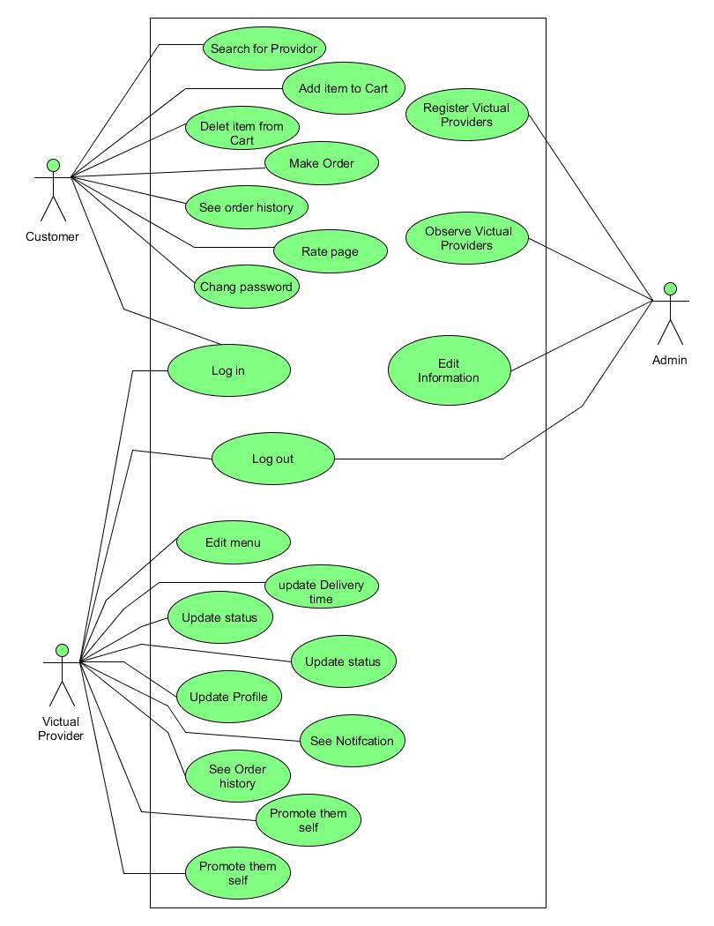

Figure 1: Use Case Diagram

### 3.2.4. Use case description

Table 1 : Use case Description for Registration

|  |  |  |
| --- | --- | --- |
| UC_ID (Use Case Description Identification Number) | UC.1 | |
| Use case name | Register | |
| Brief Description | Victual providers need to be registered by the admin before creating an account and use the system. | |
| Actor | Admin, victual provider | |
| Used use case |  | |
| Pre-condition | 1. There must be an administrator to handle the registration process.  2. The actors that are going to be registered must have a legal company. | |
| Post-condition | After registration, the registered victual provider can have access to the system by setting up their password. | |
| Flow of event | Actor | System |
| 1. Admin will open the registration page. 2. Victual provider will tell their personal information to the admin, 3. Then admin will enter the victual provider’s data and click the Register button. | 1. Check if the data entered is valid. 2. Save the data on the database. |
| Exceptional Flow | 1. If the actor enters invalid information,   * registration will be denied, * an error message will be displayed, * the actor will be asked to retry   2. if the actor is already registered,   * redirected back to the registration page, * an error message will be displayed | |

Table 2: Use case Description for Creating Account

|  |  |  |
| --- | --- | --- |
| UC_ID | UC.2 | |
| Use case name | Create an account | |
| Brief Description | The actor needs to create an account in order to use the system. | |
| Actor | Customer, victual provider | |
| Used use case |  | |
| Pre-condition | 1. Victual providers must be registered first. | |
| Post-condition | After creating account actors can have access to the system. | |
| Flow of event | Actor | System |
| 1. The actor will open the registration page. 2. Fill the form and hit submit. | 1. Check if the data entered is valid. 2. Save the data on the database. |
| Exceptional Flow | 1. If the victual provider enters invalid information,   * registration will be denied, * an error message will be displayed, * the actor will be asked to retry   2. if the victual provider is not allowed to register by the admin,   * victual provider will be notified about the situation   3. if the victual provider is already registered   * victual provider will be notified about the situation | |

Table 3: Use case Description for Authentication

|  |  |  |
| --- | --- | --- |
| UC_ID | UC.3 | |
| Use case name | Authenticate | |
| Brief Description | During the login process, the system needs to know if the user entered the same password and username as the registered one. | |
| Actor | Admin, victual provider, customer | |
| Used use case | Include: Register | |
| Pre-condition | 1. The actor must have been registered on the system.  2. The actor must have his/her own role, Email and generated password. | |
| Post-condition | 1. The actor will be authorized to use the system based on his/her role. 2. The actor will be redirected to another page or the system will display an error message it they entered the wrong credential. | |
| Flow of event | Actor | System |
| 1. The actor will open the website 2. The actor will enter the username and Password  3. The actor will click on the login button. | 1. Check if the data entered is valid. 2. The system verifies Email and the password then the actor will be redirected to homepage depending on the actor type. |
| Exceptional Flow | 1 if the actor enters invalid email or password   * The actor will be notified about the situation, * The actor will be prompted to enter email and password again, * The actor will be prompted if he/she has forgotten their password. | |

Table 4: Use case Description for Login

|  |  |  |
| --- | --- | --- |
| UC_ID | UC.4 | |
| Use case name | Login | |
| Brief Description | Actor need to login in order to use the system. | |
| Actor | Admin, victual provider, customer | |
| Used use case | Include: authenticate | |
| Pre-condition | 1. Actors must be registered 2. Actors must know their credential | |
| Post-condition | When the actor clicks the login button, the actor will be authenticated and they will be redirected if they entered correct data. | |
| Flow of event | Actor | System |
| 1. The actor will open the login page. 2. The actor will enter the credential and hit the login button. 3. Then admin will enter the victual provider’s data and click the Register button. | 1. Check if the data entered is valid. 2. Authenticate the actor and take the correct action based on the authentication result. |
| Exceptional Flow | 1. If in the system cannot find the username or the password is invalid  * An error message is displayed. * The actor can type in a new username and password or choose to cancel the operation. | |

Table 5: Use case Description for Searching

|  |  |  |
| --- | --- | --- |
| UC_ID | UC.5 | |
| Use case name | Search | |
| Brief Description | Customers have the facility to search for victual providers by location, provider name, and victual name. | |
| Actor | Customer | |
| Used use case |  | |
| Pre-condition | 1. There must be registered victual providers that are already giving service on the platform. | |
| Post-condition | The actor will be presented with a list of victual providers that much their search. | |
| Flow of event | Actor | System |
| 1. The actor must first log in to the platform.  2. The actor will enter the thing that he/she wants to search and then hit enter. | 1. The system will find results that much the customer searches. 2. After finding the search result   The system will display the search result. |
| Exceptional Flow | 1. If the system cannot find the search text specified by the user   * “Search Result Not Found” message will be displayed. | |

Table 6: Use case Description for Seeing Recommended Victual Provider

|  |  |  |
| --- | --- | --- |
| UC_ID | UC.6 | |
| Use case name | See recommended victual providers | |
| Brief Description | The system show recommended victual providers for customers which might be victual provider around their place. | |
| Actor | Customer | |
| Used use case |  | |
| Pre-condition | 1. There must be registered victual providers to be included in the recommendation. 2. The customer has to register. | |
| Post-condition |  | |
| Flow of event | Actor | System |
| 1. The customer has to login first. | 1. The system will first find the customer location. 2. After that, the system will find a list of victual providers that much the customer location. 3. Then a list of recommended victual providers will be displayed on the home page. |

Table 7: Use case Description for Visiting Victual Provider Page

|  |  |  |
| --- | --- | --- |
| UC_ID | UC.7 | |
| Use case name | Visit victual providers page | |
| Brief Description | Customers can visit any victual providers page. Victual provider profile image, menus, delivery time is included on their page. | |
| Actor | Customer | |
| Used use case |  | |
| Pre-condition | 1. Customers must log in to the system. 2. Customer should search for the specific victual providers. | |
| Post-condition | 1. Customers will be presented with a victual provider page that includes their profile image, menus and delivery time. 2. Customers will be given the facility to use a cart. | |
| Flow of event | Actor | System |
| 1. The customer has to login first. 2. Customers should search for the specific victual provider. | 1. The system will find the specified victual provider on the database. 2. The system will present the necessary victual provider data in an attractive way. |

Table 8: Use case Description for Liking Page

|  |  |  |
| --- | --- | --- |
| UC_ID | UC.8 | |
| Use case name | Like page | |
| Brief Description | Customers can like victual provider that they want to follow or that they want to keep track of their event and announcement. | |
| Actor | Customer | |
| Used use case | Include: visit page | |
| Pre-condition | 1. Customers must log in to the system. 2. Customers should visit the for the victual provider page. | |
| Post-condition | 1. Customers will get new events and announcements about the victual provider page that they like. 2. When they visit the page that they liked the like button color will be changed to show that they liked it. | |
| Flow of event | Actor | System |
| 1. The customer will log in first. 2. Customer should search for the specific victual providers. 3. The customer will then visit the victual provider page. 4. The customer will click the like button. | 1. The system will add one more like to the victual provider database. 2. And the system will change the color of the like button. |

Table 9: Use case Description for Adding Item to Cart

|  |  |  |
| --- | --- | --- |
| UC_ID | UC.9 | |
| Use case name | Add item to cart | |
| Brief Description | Before making order customers need to add victual items in the cart in that way customers can customize it before ordering. | |
| Actor | Customer | |
| Used use case |  | |
| Pre-condition | 1. There must be registered victual providers that already built their profile (added their menus). | |
| Post-condition | The actor will be presented with a list of items that they added. | |
| Flow of event | Actor | System |
| 1. The actor must first visit the specified victual provider page.  2. And then click the cart button on the menu that they want to add. | 1. The system will update the cart of the customer. |

Table 10: Use case Description for Deleting Item from Cart

|  |  |  |
| --- | --- | --- |
| UC_ID | UC.10 | |
| Use case name | Delete item from cart | |
| Brief Description | Since there is a facility for adding items to cart, there must be a way to delete an added item if customers change their mind. | |
| Actor | Customer | |
| Used use case |  | |
| Pre-condition | 1. There must be already added items in the cart. | |
| Post-condition | After deleting the item, the item will be removed from the cart. | |
| Flow of event | Actor | System |
| 1. The customer will first add an item to the cart. 2. And the customer will go to the cart. 3. Then hit the delete icon. | 1. Remove the deleted item from the cart. 2. Update the change on the cart page. |

Table 11: Use case Description for Ordering

|  |  |  |
| --- | --- | --- |
| UC_ID | UC.11 | |
| Use case name | Order | |
| Brief Description | Customers can make orders to any victual providers registered on the platform. | |
| Actor | Customer | |
| Used use case |  | |
| Pre-condition | 1. There must be orders made in the system. | |
| Post-condition | After ordering the victual provider will be notified and get the order detail. | |
| Flow of event | Actor | System |
| 1. The customer will add menus to the cart. 2. Customers will go to the cart and can also customize the quality. 3. Then all he/she has to do is hit the order button. | 1. The system will add the order to the order database. 2. The system will remove all items from the cart. |

Table 12: Use case Description for Seeing Order History

|  |  |  |
| --- | --- | --- |
| UC_ID | UC.12 | |
| Use case name | See order history | |
| Brief Description | Actor can see order made so far. | |
| Actor | Customer, Victual Provider | |
| Used use case |  | |
| Pre-condition | 1. There must be orders made in the system. | |
| Post-condition |  | |
| Flow of event | Actor | System |
| 1. The actor will go to the sidebar and click on see orders. | 1. The system will fetch the order made based on the actor.   1. And the system will display the fetched order. |
| Scenario | 1. Customer  * Customers can see order history made by him/her. * The customer will be presented with order detail including from where the customer ordered.  1. Victual Provider  * Victual provider can see order detail made by customers. * Victual providers will be presented with order details identified as unseen (new) or seen orders. |  |

Table 13: Use case Description for Updating Information

|  |  |  |
| --- | --- | --- |
| UC_ID | UC.13 | |
| Use case name | Update personal information | |
| Brief Description | The actor can update their personal information like password, name, and location. | |
| Actor | Customer, Victual provider | |
| Used use case |  | |
| Pre-condition | 1. They must be registered so there can be data to be updated. | |
| Post-condition |  | |
| Flow of event | Actor | System |
| 1. Actor will go to side bar and click on update personal information. 2. Enter updated data on the input they want to be updated and then click on update button. | 1. The system will check if the data entered is valid 2. The system will update the data on the database. 3. Display success message. |
| Scenario | 1. Customer  * Customer can update information like name, email, location, and password.  1. Victual provider  * Victual provider can update information like name, email, location, and password, cafe name, about us, cover image. |  |
| Exceptional Flow | 1. If the actor enter invalid information,   * There will not be update on the database * error message will be displayed, * the actor will be asked to retry | |

Table 14: Use case Description for Editing Menu

|  |  |  |  |
| --- | --- | --- | --- |
| UC_ID | UC.14 | | |
| Use case name | Edit menu | | |
| Brief Description | Victual provider need to add, delete and customize their menu so customers can see it and make order. | | |
| Actor | Victual provider | | |
| Used use case |  | | |
| Pre-condition | 1. They must login first. | | |
| Post-condition | The data will be updated on both the customer and victual provider side. | | |
| Flow of event | Actor | | System |
| 1. Customer will go to menus page. 2. Customer will enter data to be added including menu name, price and category. 3. After adding the menu victual provider can delete added menu. | | 1. The system will update the added or deleted menu in the database. 2. The system will reflect the change on the website. |
| Exceptional Flow | | 1. If the actor enter invalid information,   * There will not be update on the database * error message will be displayed, * the actor will be asked to retry | |

Table 15: Use case Description for Updating Delivery Time

|  |  |  |  |
| --- | --- | --- | --- |
| UC_ID | UC.15 | | |
| Use case name | Update delivery time | | |
| Brief Description | Victual provider can add, delete and customize their delivery time so customers can see it and make order accordingly. | | |
| Actor | Victual provider | | |
| Used use case |  | | |
| Pre-condition | 1. They must login first. | | |
| Post-condition | The data will be updated on both the customer and victual provider side. | | |
| Flow of event | Actor | | System |
| 1. Customer will go delivery schedule page. 2. Customer will enter schedule to be added which is the time to deliver. 3. After adding the delivery time victual provider can delete added delivery schedule. | | 1. The system will update the added or deleted delivery time in the database. 2. The system will reflect the change on the website. |
| Exceptional Flow | | 1. If the actor enter invalid information,   * There will not be update on the database * error message will be displayed, * the actor will be asked to retry | |

Table 16: Use case Description for Updating Status

|  |  |  |
| --- | --- | --- |
| UC_ID | UC.16 | |
| Use case name | Update status | |
| Brief Description | Victual providers can update their status if they are closed or opened. | |
| Actor | Victual provider | |
| Used use case |  | |
| Pre-condition | 1. They must login first. | |
| Post-condition | The data will be updated on both the customer and victual provider side. | |
| Flow of event | Actor | System |
| 1. Customer will go to delivery time. 2. Change open to close or close to open and hit update. | 1. The system will update the status in the database. 2. The system will reflect the change on the website. |

Table 17: Use case Description for Seeing Notification

|  |  |  |
| --- | --- | --- |
| UC_ID | UC.17 | |
| Use case name | See notification | |
| Brief Description | Victual providers do not need to reload the order history the system will notify them when there is order. | |
| Actor | Victual provider | |
| Used use case |  | |
| Pre-condition | 1. There must be new orders made in the system. | |
| Post-condition |  | |
| Flow of event | Actor | System |
| 1. Victual provider should only open the home page. | 1. The system will check if there is order in one second interval.   1. If there is order the system will update the notification icon and display the number of notification on the icon. |

Table 18: Use case Description for Promotion

|  |  |  |  |
| --- | --- | --- | --- |
| UC_ID | UC.18 | | |
| Use case name | Promote | | |
| Brief Description | The platform gives facility for victual providers to promote their services so they can reach many customers. | | |
| Actor | Victual provider | | |
| Used use case |  | | |
| Pre-condition | 1. They must give service on the platform | | |
| Post-condition | Many customers will see the promotion. | | |
| Flow of event | Actor | | System |
| 1. Victual provider will go to side bar and click on promote. 2. And then they will fill promotion detail. 3. And click on promote. | | 1. The system will validate the entered data.   1. And the system will show the promotion for customers. |
| Exceptional Flow | | 1. If the Victual provider enter invalid information,   * error message will be displayed, * the actor will be asked to retry | |

Table 19: Use case Description for Posting Event

|  |  |  |  |
| --- | --- | --- | --- |
| UC_ID | UC.19 | | |
| Use case name | Post event | | |
| Brief Description | The platform gives facility for victual providers to post event for example when there is concert at their hotel. | | |
| Actor | Victual provider | | |
| Used use case |  | | |
| Pre-condition | 1. They must login first. | | |
| Post-condition | Customers will see the event. | | |
| Flow of event | Actor | | System |
| 1. Victual provider will go to side bar and click on post event. 2. And then they will fill event detail. 3. And click on post. | | 1. The system will validate the entered data.   1. And the system will include the event on their page. |
| Exceptional Flow | | 1. If the Victual provider enter invalid information,   * error message will be displayed, * the actor will be asked to retry | |

Table 20: Use case Description for Editing Victual Provider Information

|  |  |  |  |
| --- | --- | --- | --- |
| UC_ID | UC.20 | | |
| Use case name | Edit victual provider information | | |
| Brief Description | After victual providers are registered if there is something to be edited, the administrator has access to edit. | | |
| Actor | Admin | | |
| Used use case |  | | |
| Pre-condition | 1. Victual provider must be registered. | | |
| Post-condition |  | | |
| Flow of event | Actor | | System |
| 1. Admin will go to side bar and click on show victual provider. 2. And click edit on the victual provider that she/he wants to edit. 3. Then fill the updated data and hit update. | | 1. The system will validate the entered data.   1. And the system will update the change on the database. |
| Exceptional Flow | | 1. If the Victual provider enter invalid information,   * error message will be displayed, * the actor will be asked to retry | |

Table 21: Use case Description for Logout

|  |  |  |
| --- | --- | --- |
| UC_ID | UC.21 | |
| Use case name | Logout | |
| Brief Description | After finishing the system actor can logout from the system. | |
| Actor | Admin, victual provider, customer | |
| Used use case |  | |
| Pre-condition | actor should login first | |
| Post-condition | Actor will be redirect to login page and need to login again to access the system. | |
| Flow of event | Actor | System |
| 1. Actor will go to side bar.   2. Actor will click on logout button. | 1. Delete session data related to login. 2. Redirect to login page. |

### 3.2.5. Activity diagram

The activity diagram is one of the UML diagrams associated with the object-oriented approach, but it can be used with any development approach. An activity diagram is simply a workflow diagram that describes the various user (or system) activities, the person who does each activity, and the sequential flow of these activities. Diagrams describe the workflow behavior of a system. The propose system is described by the following activity diagram that represent the flow of one use case from one activity to another activity [2].

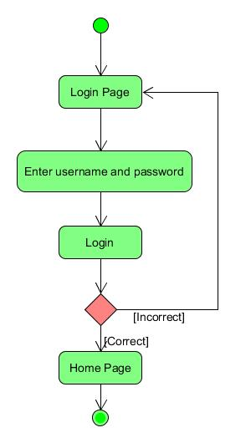

Figure 2: Activity Diagram for Login

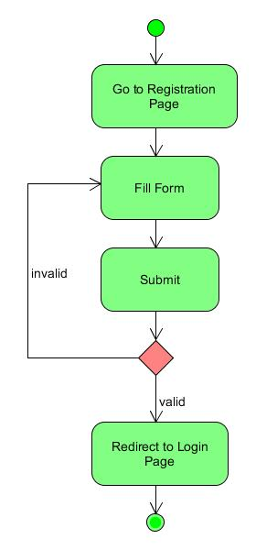

Figure 3: Activity Diagram for Creating Account

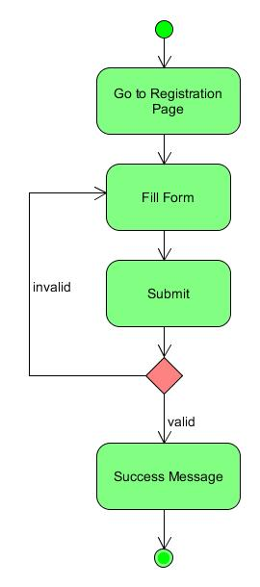

Figure 4: Activity Diagram for Victual Provider Registration

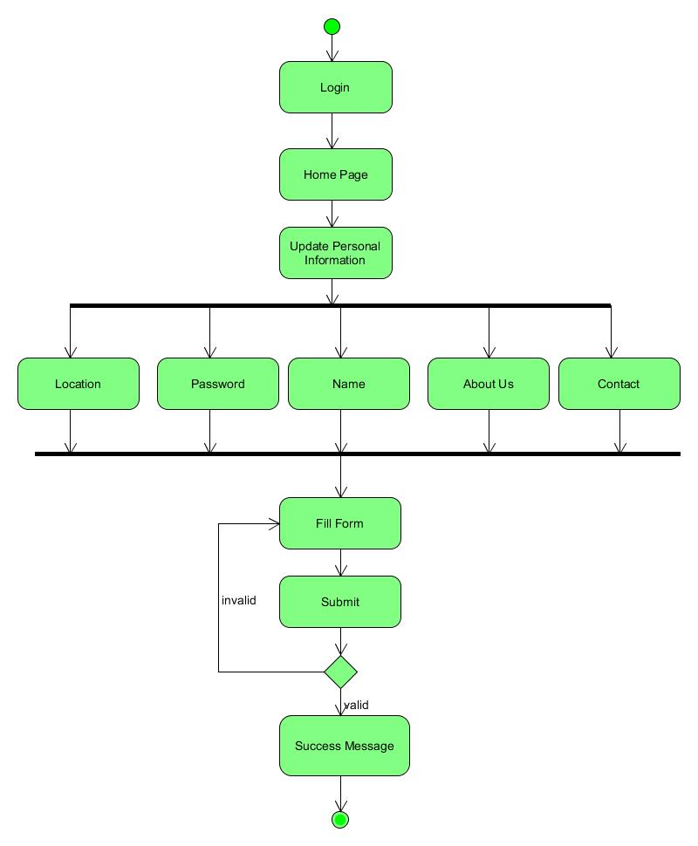

Figure 5: Activity Diagram for Victual Provider Update Information

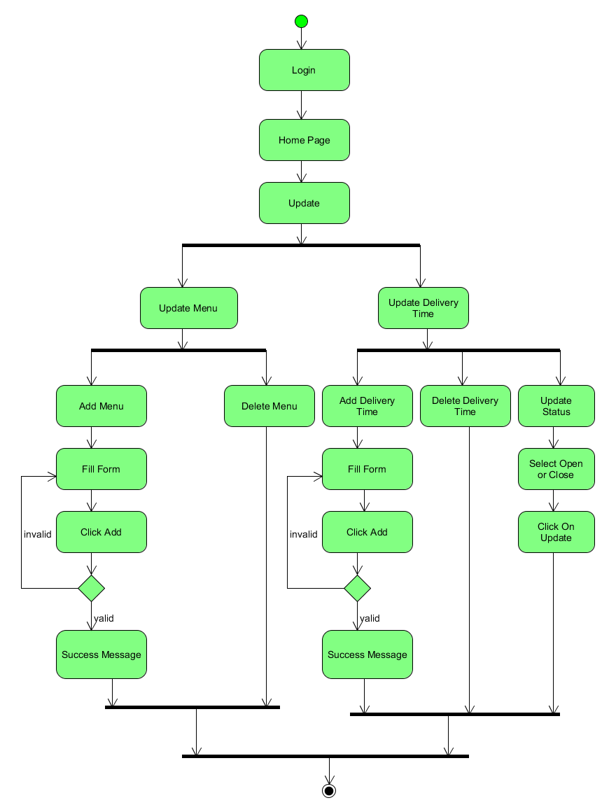Figure 6: Activity Diagram for Updating Victual Provider Service and Delivery Time

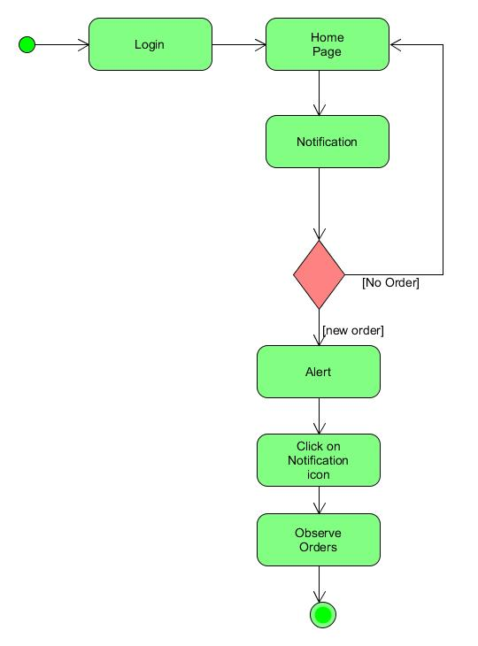

Figure 7: Activity Diagram for Notification and Order History

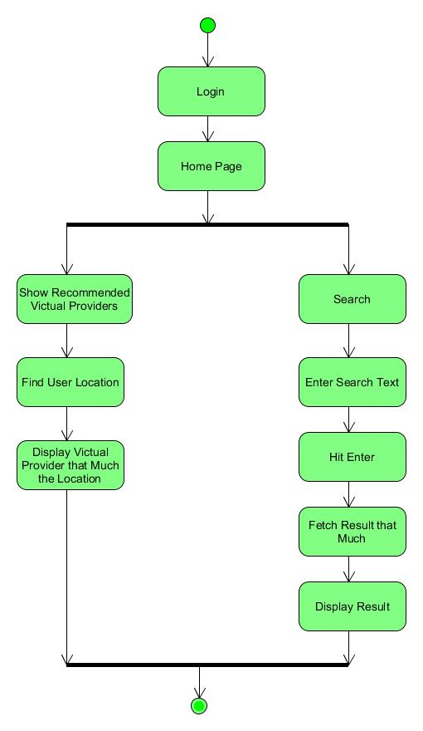

Figure 8: Activity Diagram for Finding Victual Provider

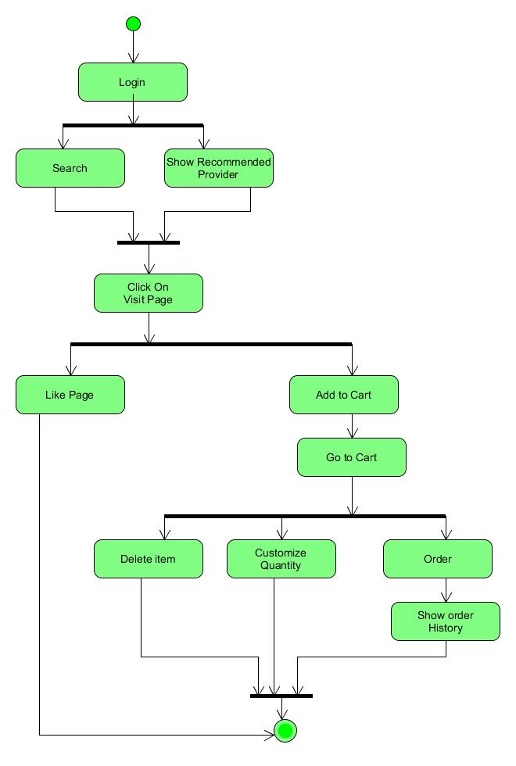

Figure 9: Activity Diagram for Ordering

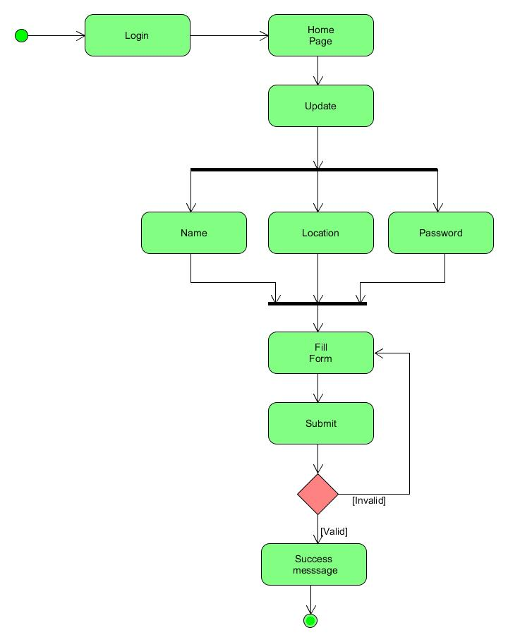

Figure 10: Activity Diagram for Updating Personal Information

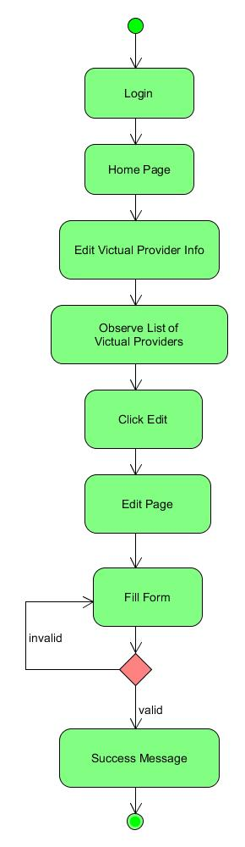

Figure 11: Activity Diagram for Admin Control System

## Dynamic Modeling

Previous modeling notations represent static elements of the requirement model. The dynamic  
model represents system’s behavior as a function of specific events and time. Dynamic Modeling also used to represents the interaction, workflow, and different states of the static constituents in software. This section show the basic behavioral models i.e. sequence and state diagram [3].

### Sequence Diagram

A sequence diagram is an interactive diagram that shows how objects operate with one another and in what order. It shows object interactions arranged in time sequence. Sequence Diagrams describe patterns of communication among a set of interacting objects [4]. An object interacts with another object by sending messages. This type of role is known as a dynamic role. The main sequence diagrams identified in our project are presented as follows.

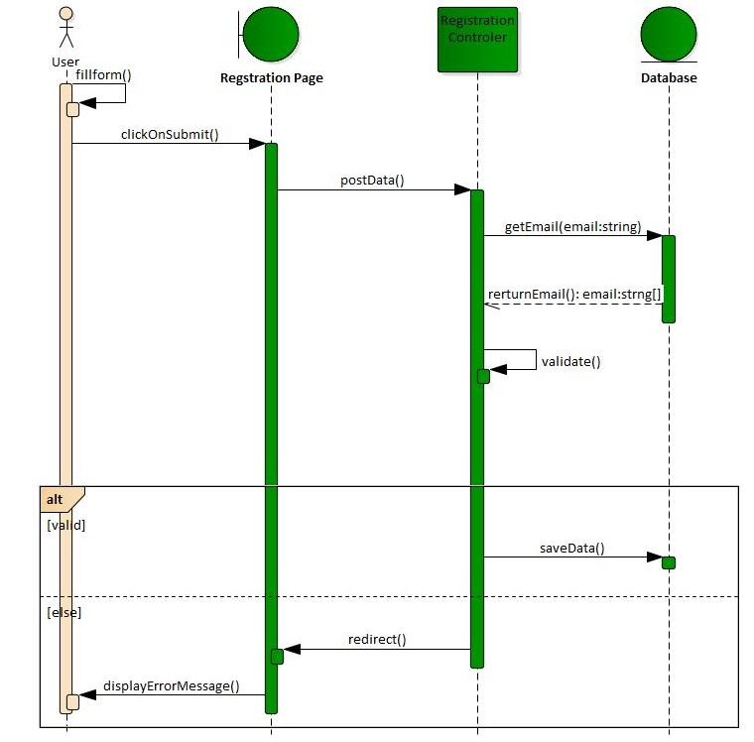

Figure 12: Sequence Diagram for Registration

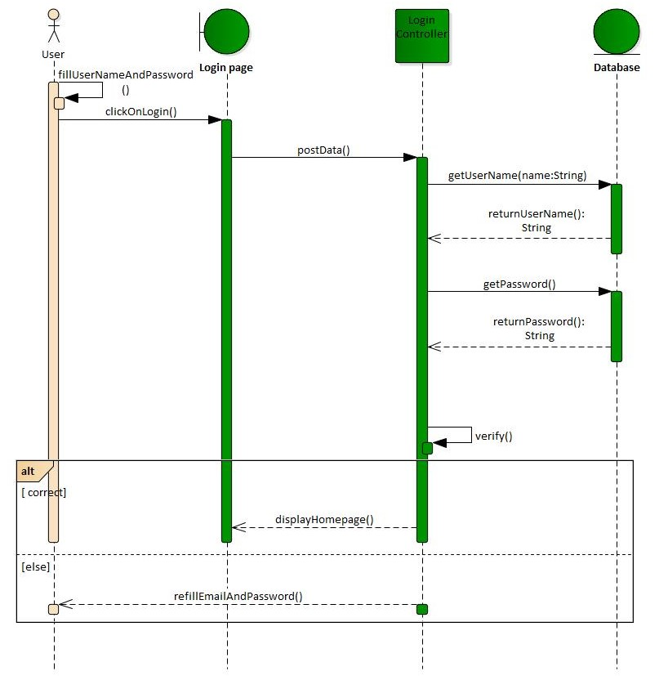

Figure 13: Sequence Diagram for Login

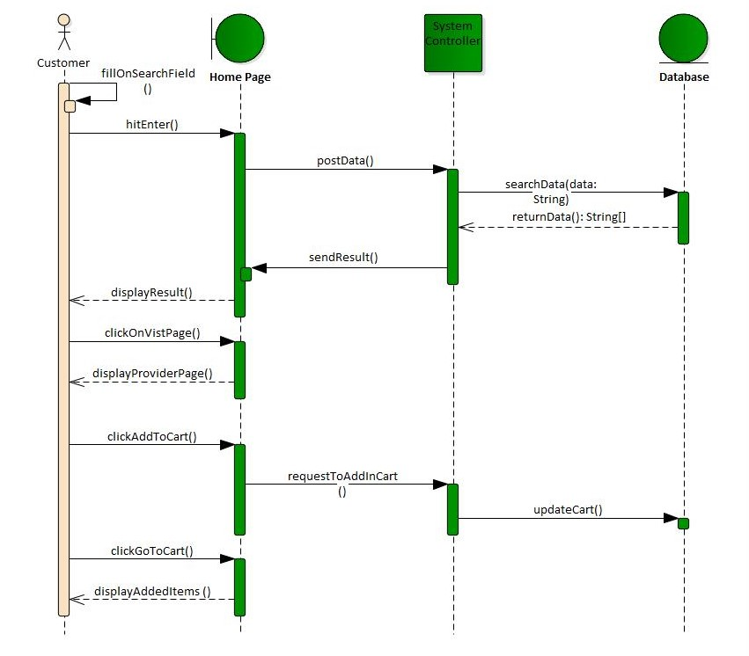

Figure 14: Sequence Diagram Customer Interaction with System

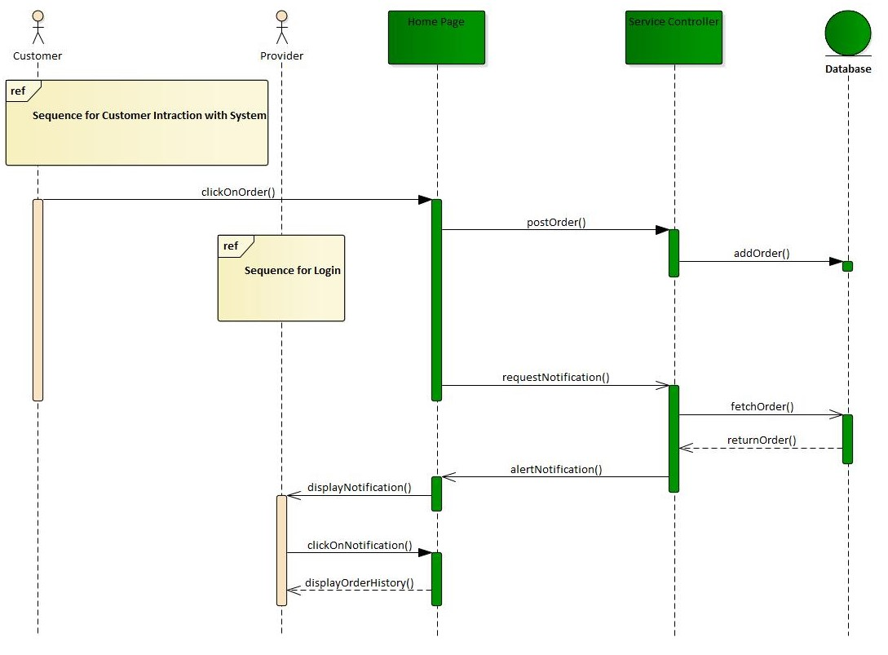

Figure 15: Sequence Diagram for Customer and Provider Interaction

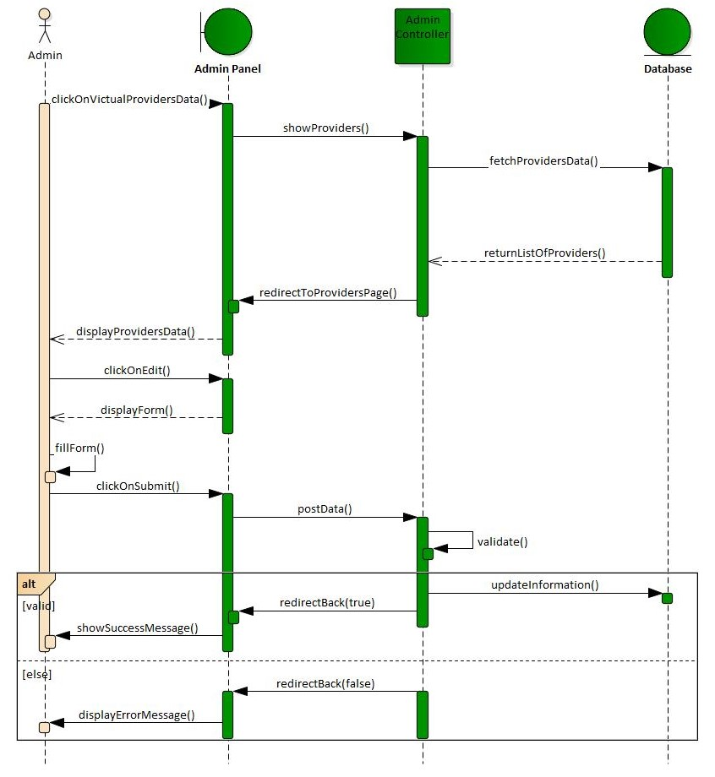

Figure 16: Sequence Diagram for Admin Control system

#### State Diagram

A state diagram is type of diagram that describes the behavior of the system. It is essential to understand the instant condition or "run state" of a model when it executes. State diagrams are used to give an abstract description of the behavior of a system [5]. This behavior is analyzed and represented in series of events that could occur in one or more possible states. Some of the sample state diagram displayed below.

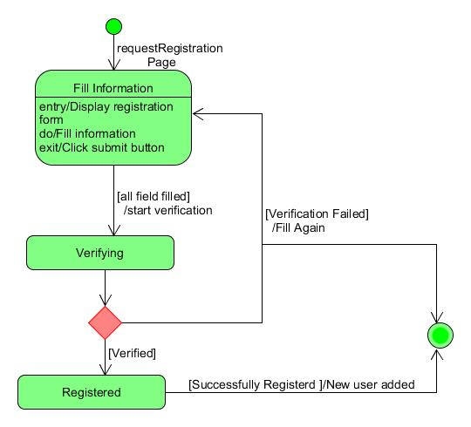

Figure 17: State Diagram for User Registration

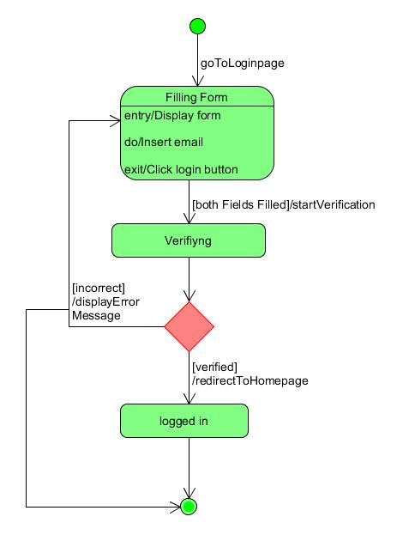

Figure 18: State Diagram for Login Authentication

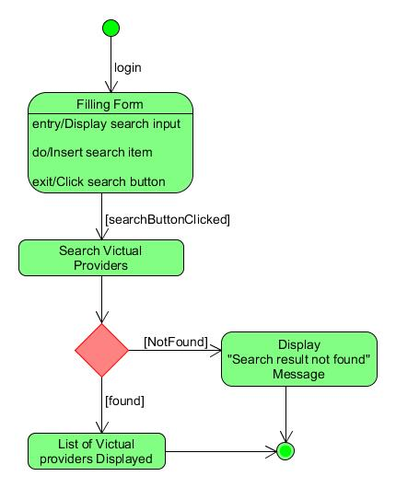

Figure 19: State Diagram for Customer Searching Victual Providers

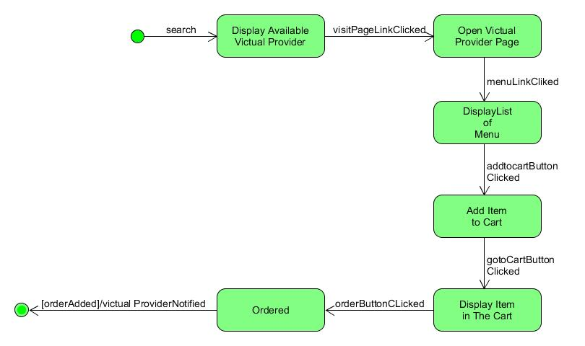

Figure 20: State Diagram for Customer Ordering

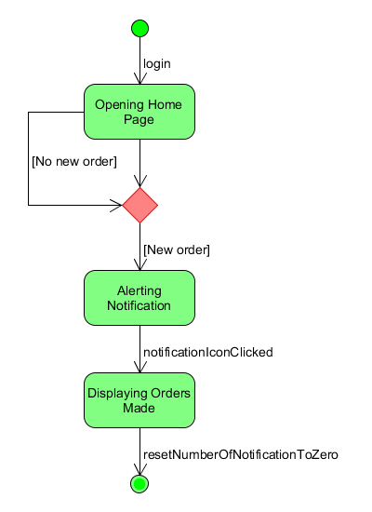

Figure 21: State Diagram for Provider to Observe Order History

## Class-Based Modeling

A class model captures the static structure of a system by characterizing the objects in the  
system, the relationship between the objects, and the attributes and operation for each class of  
object [6]. In this part of document we want to show how we structured the system at the level of classes and how these classes relate to each other and their multiplicity.

* + 1. **Identifying Classes**
* User
* Victual Provider
* Customer
* Admin
* Order
* Order Detail
* Cart
* Menu
* Delivery Time
* Post
* Provider Status
* Like
  + 1. **Class Diagram**

A class diagram is an illustration of the relationships and code dependencies among classes in  
the UML. A class defines the attributes and operations in an object, which is a specific entity in a program or the unit of code representing that entity. Class diagrams are useful in all forms of OOP. In this project we will show class diagram for each of modules. The following diagram shows the class diagram that shows the interactions between different classes of the system.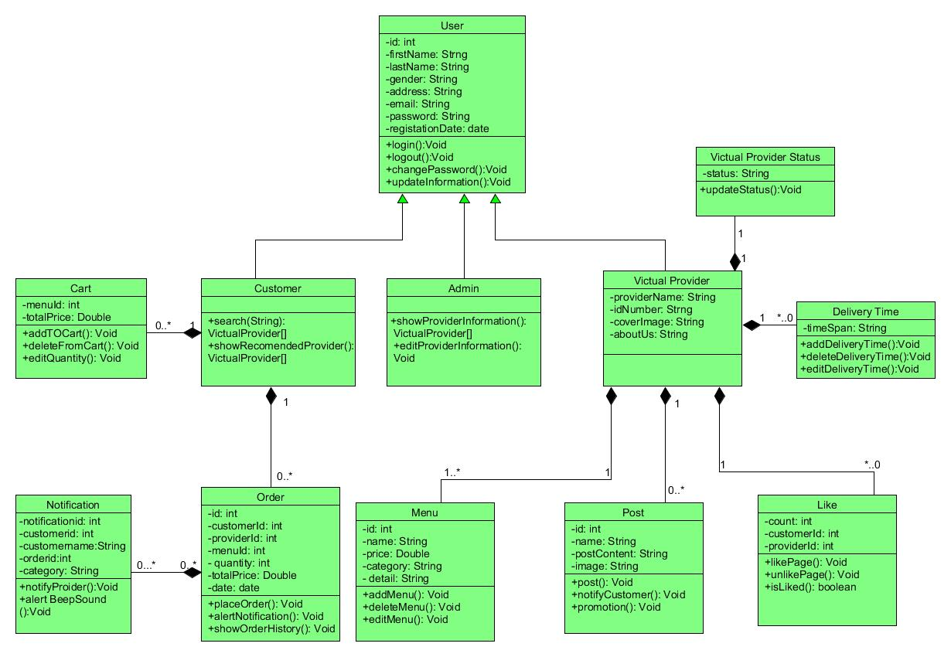

Figure 22: Class Diagram

# Chapter Four: System Design

## 4.1 Overview of System Design

So far we have been analyzing the requirement, the problem, and the interaction of the system with different actors in this phase we will dig deep in to the system design which includes defining the architecture, module, interface and data for a system to satisfy the requirements that we stated on previous chapters. In this phase we are going to design the bridge that fill the gap between problem domain and existing system. Since system design focuses on how to implement the system, we will transform the SRS document and the analysis model in to format that can be implemented and decides how the system will operate.

## 4.2 System Design

System **design** is the process of designing the elements of a system such as the architecture, modules and components, the different interfaces of those components and the data that goes through that system. In this phase, the complex activity of system development is divided into several smaller sub-activities, which coordinate with each other to achieve the main objective of system development [7].

### 4.2.1. Design Goal

Design goals are expected qualities that the system should have. It is easy way to control the implementation tools to achieve best results. The following are the design goals of the digital platform for victual provider that should be considered in designing the system.

**Reusability**

It is one of the important design goals of our system. We aim to extract as much general functionality into modules or libraries so we can reuse this functionality in other applications or when it is needed. This will help us to finish the project in less amount of time and it reduces cost of production.

**Correctness**

The term correctness is the ability of software products to perform their exact tasks, as defined by their specification [8]. As much as possible a system must behave correctly when users interact with the system and there shouldn’t be any defect. When we come to our project we are going to keep this as rule for developing our system. We will attempt to develop a system that can fulfill the functional requirements that we have discussed in chapter two.

**Usability**

Since any system is built for peoples we value the usability of a system a lot. We will try to build a system that anybody can find it easy, attractive, and exciting to use. We will take care of every decision we are going to make when designing the interface from choosing color and font to designing the whole interface. We will keep the interface consistence for people to find it easy to learn.

**Robustness**

Robustness is the ability of tolerating misuse and resisting change without affecting the previous configuration of the system [9]. We will try to achieve robustness in the following way

* by documenting our code
* **by including test set that can be run to ensure the software is actually working**
* **by reusing codes**
* by using data abstraction and encapsulation
* by initializing variables
* qualifying all inputs

**Flexibility**

Flexibility refers to the ability for the solution to adapt to possible or future changes in its requirements [10].We will try to achieve flexibility by minimizing coupling between components.

**Efficiency**

We planned to use resources such as memory size, processor, and network speed efficiently by using better data structure and algorithm.

1. **System Decomposition**

We decomposed the system into user subsystem, provider subsystem, control subsystem, order subsystem and finder subsystem.

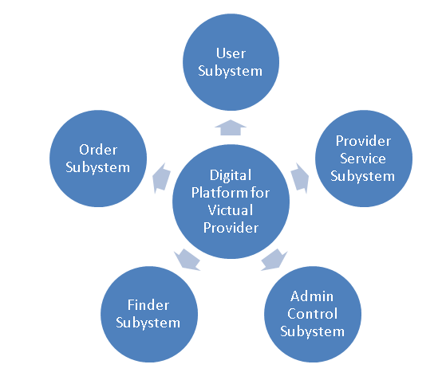

Figure 23: System Decomposition

1. **User Subsystem**

This module wraps functionality such as create, update, control and manage account and also login and logout for customer, victual provider, and admin.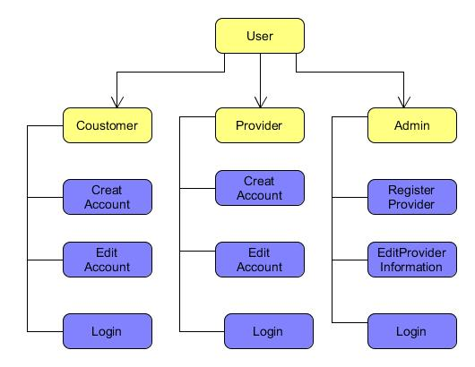

Figure 24: User Subsystem

**Processing**

1. **Creating Account**

Victual provider and customer create account in order to access the system. Victual provider must get permission from admin before creating account so victual provider is registered by admin. The following processes are needed:-

* User will fill information needed and submit
* Verify information and register user
* Redirect to login page

|  |  |
| --- | --- |
| Customer | Victual Provider |
| * ID * First name * Last name * Gender * Phone number * Address * Email * Password * Registration date | * ID * First name * Last name * Gender * Phone number * Address * Email * Cafe name * ID Number * Password * Registration date |

Table 22: User Account Data

1. **Edit account**

Victual provider and customer can edit their information stated in table 21. The following processes are needed:-

* Provide interface to fill information
* Validate information
* The data will be updated

1. **Login**

Victual provider, customer and admin must login in order to access the system and the following process is needed:-

* Login page will be provided
* Fill information then click login
* Authenticate and redirect to home page

1. **Logout**

Victual provider, customer and admin can logout after accessing the system and the following process is needed:-

* Logout button will be provided
* Login session data will be destroyed
* Redirect to login page

1. **Provider Service Subsystem**

This module is concerned with helping victual provider to build their profile and to give service on the platform. This module contains components to edit menu, edit delivery time, post event and promote their service.

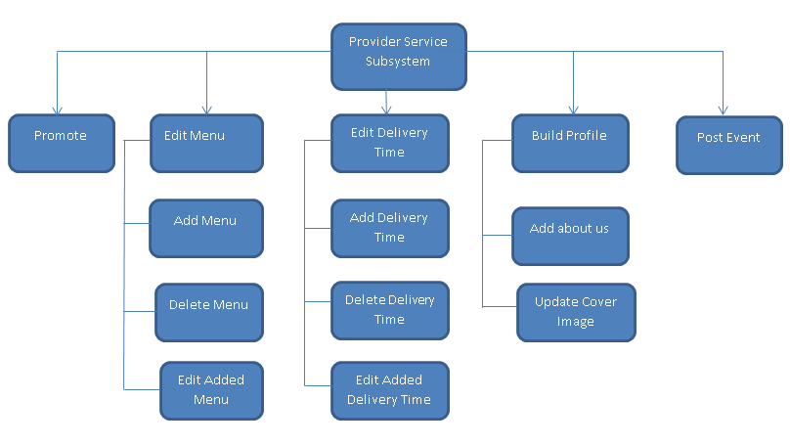

Figure 25: Provider Service Subsystem

**Processing**

1. Edit Menu

Victual provider can add, delete, and edit menus that will be added on the provider page. The following processes are needed:-

1. Add menu

* Provide the interface to add the price, menu name, category, and detail about the menu.
* User will fill needed information about the menu
* Validate the information
* Add the menu on the database

1. Delete menu

* Provide delete icon on each added menu
* Remove menu when delete icon clicked

1. Update menu

* Provide edit button on each added menu
* Provide interface to fill information
* Edit the existing menu when the user request to edit

1. Edit Delivery Time

Victual provider can add, delete, and edit delivery time that will be added on the provider page. The following processes are needed:-

1. Add delivery time

* Provide the interface to add delivery time
* User will fill needed information
* Validate the information
* Add the delivery time on the database

1. Delete delivery time

* Provide delete icon on each added delivery time
* Remove delivery time when delete icon clicked

1. Update delivery time

* Provide edit button on each added delivery time
* Provide interface to fill information
* Edit the existing delivery time when the user request to edit

1. Post Event

Victual provider can add, delete, and edit post that will be added on the provider page. The following processes are needed:-

1. Post

* Provide the interface to fill information such as post data and posted image
* User will fill needed information
* Validate the information
* Post on the victual providers page

1. Delete post

* Provide delete icon on each added post
* Remove post when delete icon clicked

1. Edit post

* Provide edit button on each added post
* Provide interface to fill information
* Edit the existing post when the user request to edit

1. Promote

Victual provider promote the existing posts so they can reach many customers. The following processes are needed:-

* Provide promote button on posts
* Provide interface to select types of customers victual wants to reach by city, age, gender
* When user request to promote, it will show customers when visiting their page

1. Build Profile

Victual provider can edit their profile such as about us and cover image that will be added on the provider page. The following processes are needed:-

* Provide interface to fill information
* Validate information
* The data will be updated on the provider page

|  |  |  |  |
| --- | --- | --- | --- |
| Menu | Delivery Time | Post | Profile |
| * Item name * Price * Category * Detail | * time interval | * posted text * image | * about us * cover image |

Table 23: data table for menu, delivery time, post and profile

1. **Admin Control Subsystem**

There are certain activities that need the administrator interference. Victual provider need to be registered by the admin before creating account. And registering victual provider, editing information and observing victual provider are included in module.

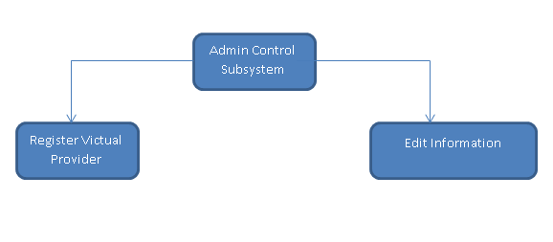

Figure 26: Admin Control Subsystem

**Processing**

1. Register Victual Provider

Here admin give permission for victual to create account and the following processes are needed:-

* Provide registration page to fill information
* Validate filled data
* add victual provider on the database

1. Edit Registered Provider

* Provide interface to show list of provider already registered on the system
* Provide edit button on every listed victual provider
* Provider edit page to edit data and to fill information
* Validate filled information and update the change on the database

1. **Finder Subsystem**

This module comprises of components that help customer to find the right victual provider. The included components are search and show recommended victual provider.

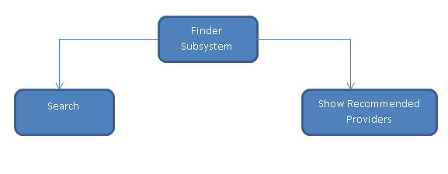

Figure 27: Finder Subsystem

**Processing**

1. **Search**

The customer can search for victual provider by location, provider name and victual name. The following processes are needed:-

* Provide search input
* After data filled and request to search sent
* Fetch victual provider that much the search result
* Display all victual provider found

1. **Show recommended victual provider**

This component provide facility to track the customer location and to show victual provider around customer location when customer visits the home page. The following processes are needed:-

* Find the customer location
* Find victual provider on that location
* Display the founded victual provider

1. **Order Subsystem**

This module is comprises of components such as cart system, ordering, notification and viewing order history.

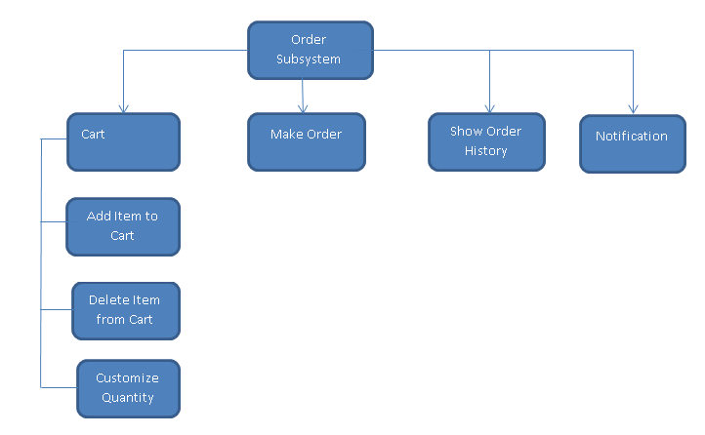

Figure 28: Order Subsystem

**Processing**

1. **Cart**

Victual provider can add item to cart, delete item from cart, and customize quantity. The following processes are needed:-

a. Add item to cart

* Provide the interface to add cart on victual provider’s page.
* When add to cart icon clicked
* The menu will be added to cart

1. Delete item from cart

* Provide delete icon on each added item on the cat
* Remove item from the when delete icon clicked

1. Customize quantity

* Provide input to insert amount of item that the customer want.
* Validate entered quantity
* Update the quantity when ordering

1. **Make order**

Customer can order items added to cart. The following processes are needed:-

* Provide order button on the cart page
* When customer request to order add the order on the database

1. **Show order history**

Both victual provider and customer can see order history. The following processes are needed:-

* Provide link to show list of orders made
* When show order history clicked orders will be fetched from the database
* Display the fetched orders

1. **Notification**

This component is responsible to alert notification when there is new order. The following processes are needed:-

* Provide notification icon to show number of notifications
* Check for new order in one second interval
* When there is new order alert notification

## 4.3 Architecture of the System

**4.3.1. Architecture Style and Pattern**

**Architectural Style**

The architectural style is a very specific solution to particular software which typically focuses on how to organize the code created for the software [11]. We will be using these two architectural styles that can work together.

1. **Object oriented architectural style**

Object Oriented Architecture is an important concept for developing the software. It is a design paradigm based on the division of responsibilities for an application or system into individual reusable and self-sufficient objects. We choose object oriented architecture because of the following reasons:-

* Object-Oriented architecture maps the application to real world objects for making it more understandable.
* It is easy to maintain and improves the quality of the system due to program reuse.
* This architecture provides reusability through inheritance.
* It has ability to manage the errors during execution (Robustness).
* It has ability to extend new functionality and has not effect on the system (Flexibility).
* It improves testability through encapsulation.
* Object-Oriented architecture reduces the development time and cost.
* Object-Oriented architectural style is easy for group of programmers working together.

1. **Data centered architectural style**

A data store will reside at the center of this architecture and is accessed frequently by the other components that update, add, delete or modify the data present within the store. Since we are building a web based system there will be a database that will be accessed by the entire component in our system and the website use the database. This architectural style can work with Object-Oriented architectural style. The object identified in Object-Oriented architectural style will use the database to update, insert, and fetch data. In this diagram we tried to show how the classes that we identified on class based modeling works with the database.

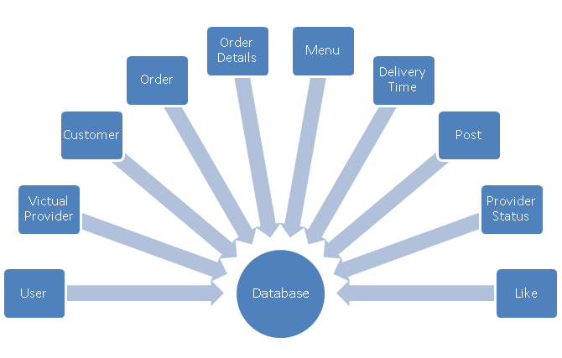

Figure 29: Object-Oriented and Data Centered Architectural Style

**Architectural Pattern**

An architectural pattern is a general, reusable solution to a commonly occurring problem in software architecture within a given context. Our system has three different parts integrating to make the whole system [12]. Those parts are:-

* View:this part of the system is where the user directly interacts with the system. For example user inserts data on the provided interface.
* Controller: this part of the system is where all business logic happened. For example validating the user data entered through the view.
* Model: The Model component corresponds to all the data-related logic that the user works with which is the database in our case.

As we mentioned earlier our system mostly works by exchanging data from the view through the controller to the database and this process is repeated many times in the system and that is why we planned to use **MVC (model-view-controller)** architectural pattern. The Model-View-Controller (MVC) is an architectural pattern that separates an application into three main logical components: the model, the view, and the controller. Each of these components is built to handle specific development aspects of an application.

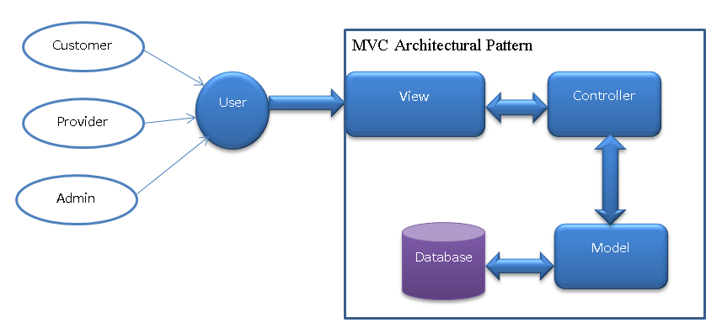

Figure 30: MVC Architectural Pattern

**4.3.2. Component Diagram**

Component diagrams are used to visualize the organization and relationships among components in a system [13]. These diagrams are also used to make executable systems.In this diagram we tried to show the relationship between the components such as user subsystem, admin control subsystem, order subsystem, finder subsystem, and provider service subsystem.

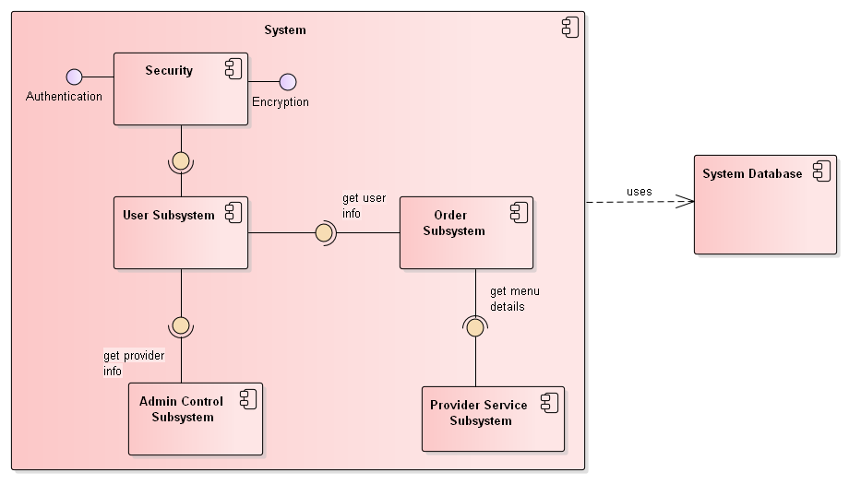

Figure 31: Component Diagram

**Component Description**

1. **User Subsystem**

This component wraps functionality such as create, update, control and manage account and also login and logout for customer, victual provider, and admin.

1. **Security**

This component is responsible for securing the system by using encryption and authentication.

1. **Provider Service Subsystem**

This component is concerned with helping victual provider to build their profile and to give service on the platform. This module contains functionalities to edit menu, edit delivery time, post event and promote their service.

1. **Control Subsystem**

There are certain activities that need the administrator interference. Victual provider need to be registered by the admin before creating account. And registering victual provider, editing information and observing victual provider are included in component.

1. **Finder Subsystem**

This component comprises of functionalities that help customer to find the right victual provider. The included components are search and show recommended victual provider.

1. **Order Subsystem**

This component is comprises of functionalities such as cart system, ordering, notification and viewing order history.

1. **System database**

This is a component which the entire system uses. This component is concerned with storing data collected through the other components.

**4.3.3. Deployment Diagram**

A Deployment diagram shows how and where the system is to be deployed. Deployment diagram typically used to visualize the physical hardware and software of a system [14]. In this diagram we tried to depict how our system deployed on physical device.

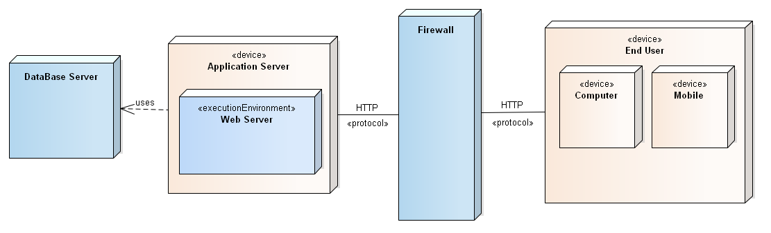

Figure 32: Deployment Diagram

**4.4 Access Control**

Access control is a way of limiting access to a system. Access control is a process by which users (customer, administrator, and victual provider in our case) are granted access and certain privileges to systems, resources or information. In this section we attempted to specify access permission of the subsystem for each actor.

|  |  |  |  |  |  |
| --- | --- | --- | --- | --- | --- |
| Actor | User Subsystem | Admin Control Subsystem | Provider Service Subsystem | Finder Subsystem | Order Subsystem |
| Customer | YES | NO | YES | YES | YES |
| Victual Provider | YES | NO | NO | NO | YES |
| Administrator | YES | YES | NO | NO | NO |

Table 24: Access Control Table

**4.5 Database Design**

**Database Design** is a collection of processes that facilitate the designing, development, implementation and maintenance of enterprise data management systems. Properly designed database are easy to maintain, improves data consistency and are cost effective in terms of disk storage space. Here we identified data that must be stored and how the identified data element interrelates. By using Entity Relationship diagram we showed the organization of the data’s and relationship between a set of data’s.

­­­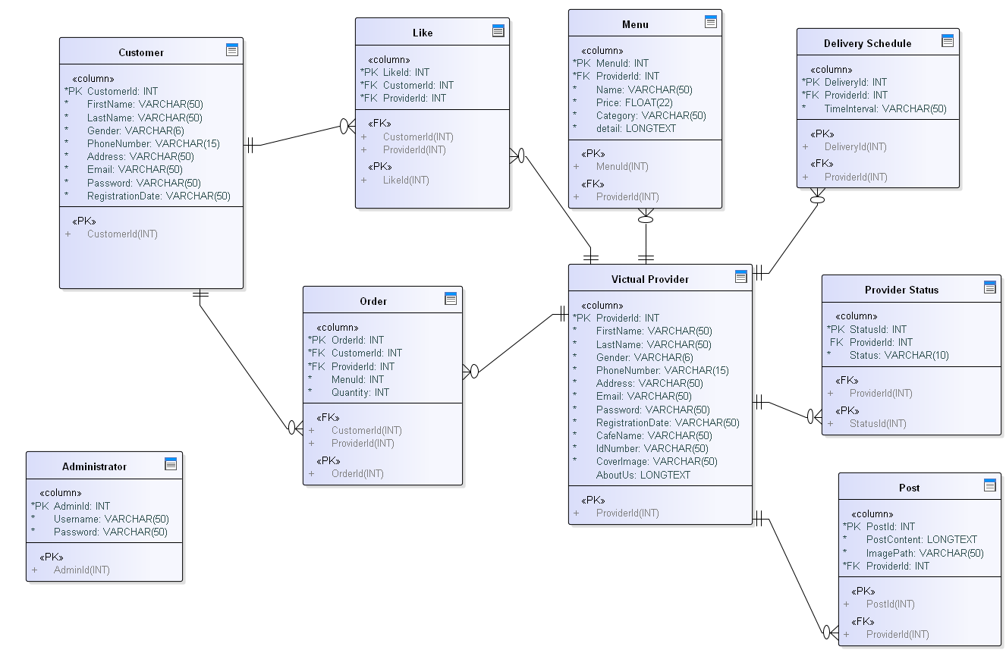­­­­­­­

Figure 33: Entity Relationship Database Design Diagram

## 4.6 **User Interface Design**

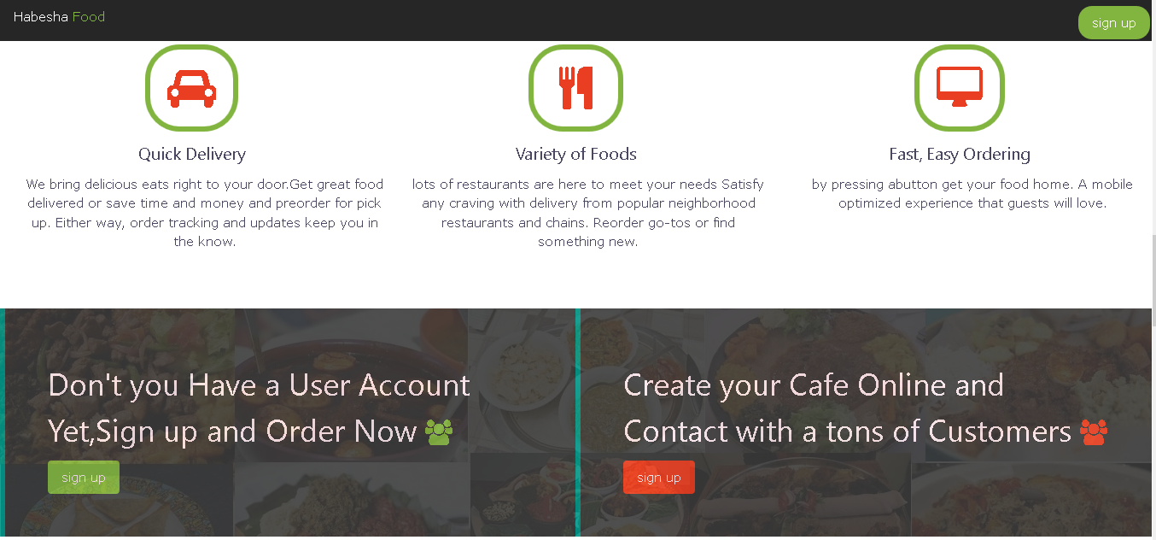

Figure 34: Home page

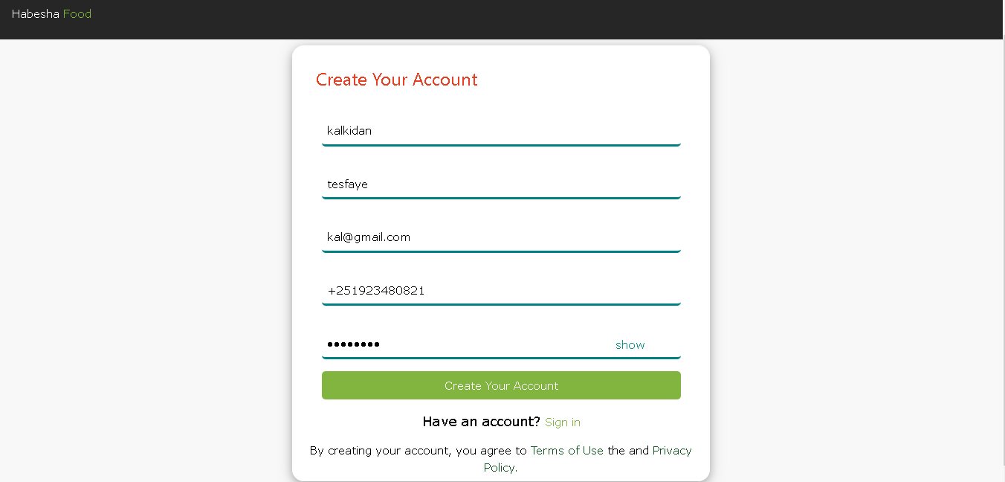

Figure 35: Registration Page for Customer

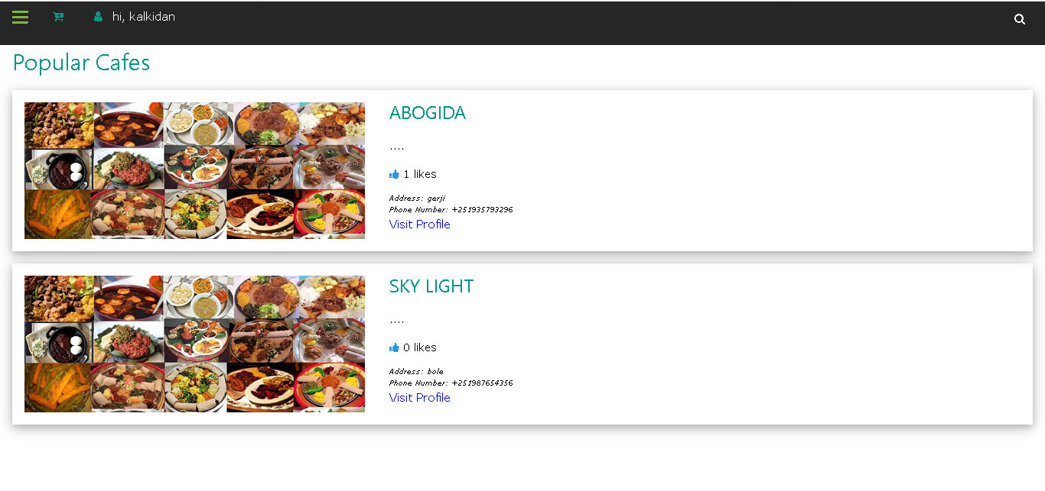

Figure 36: Customer Home Page

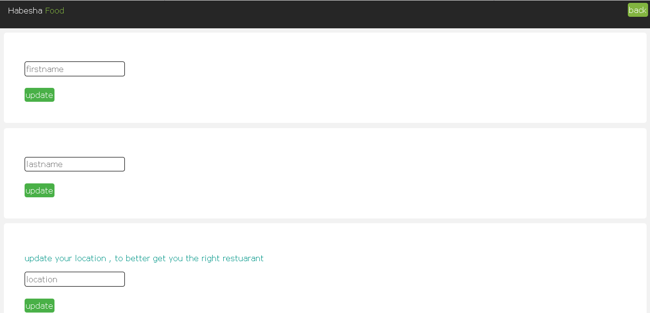

Figure 37: Update Info Page

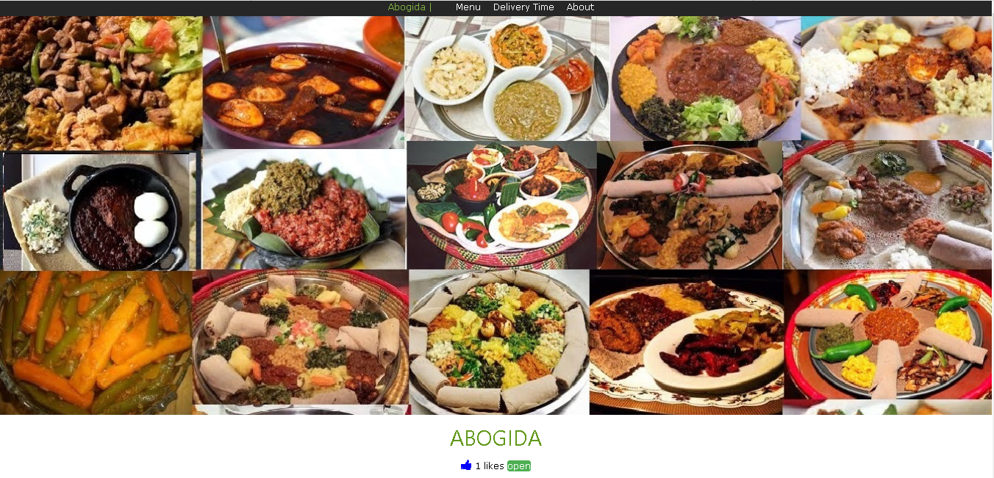

Figure 38: Provider page

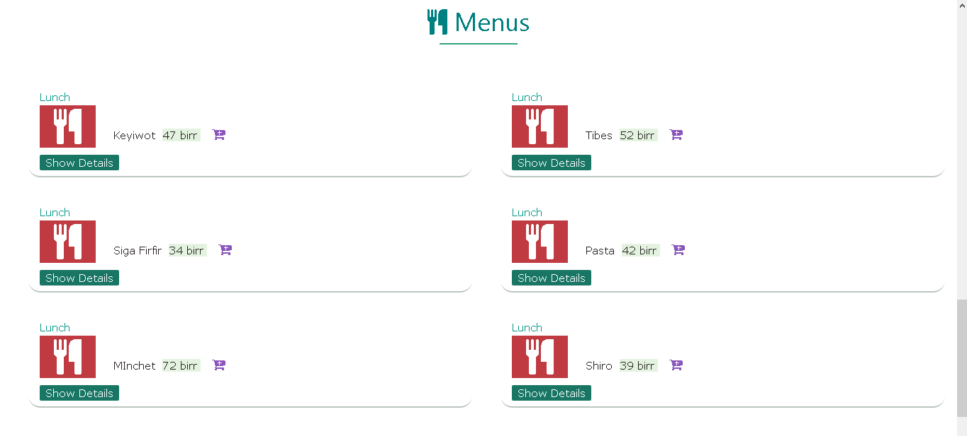

Figure 39: Menus Page

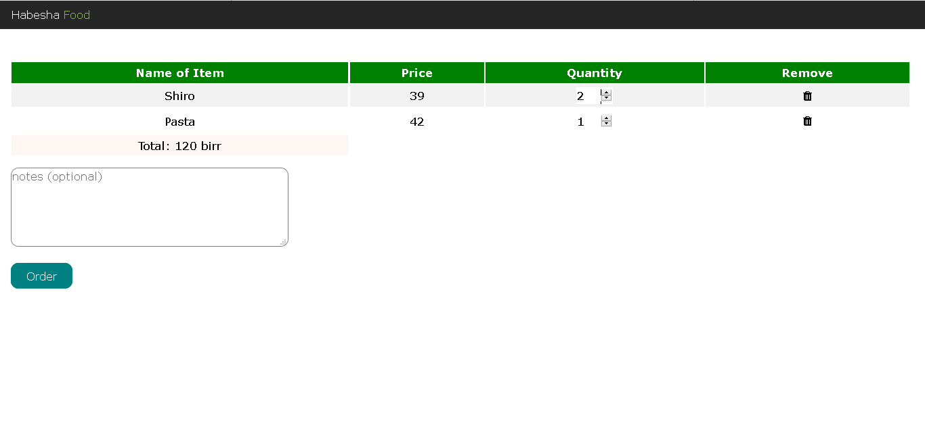

Figure 40: Cart Page

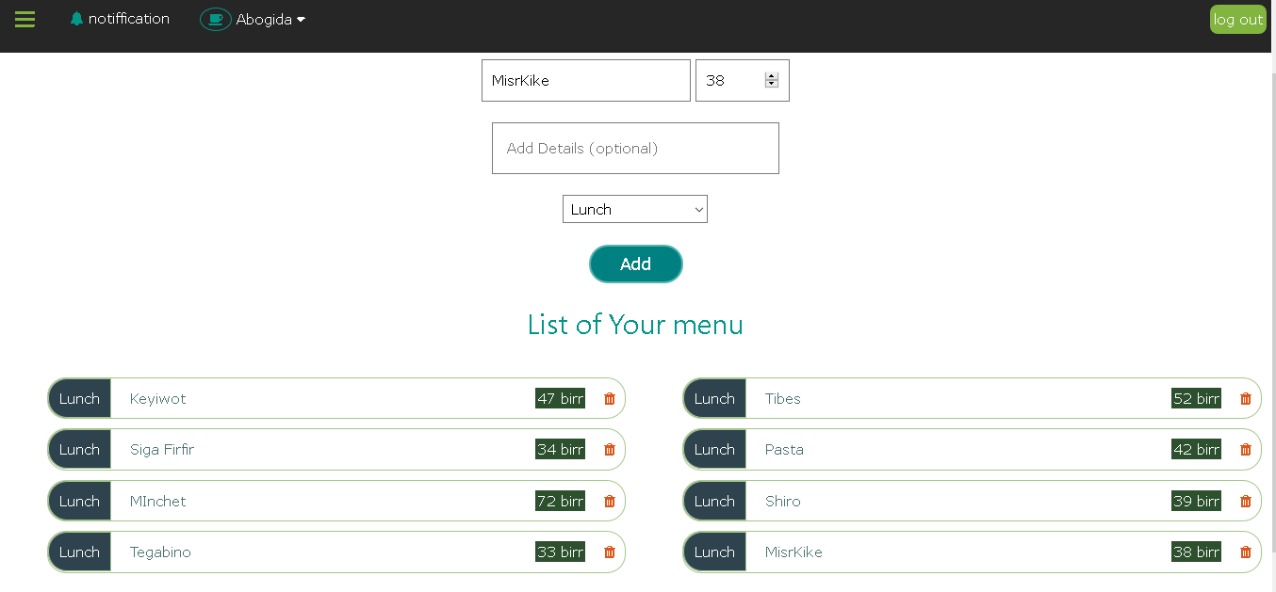

Figure 41: Add Menu Page

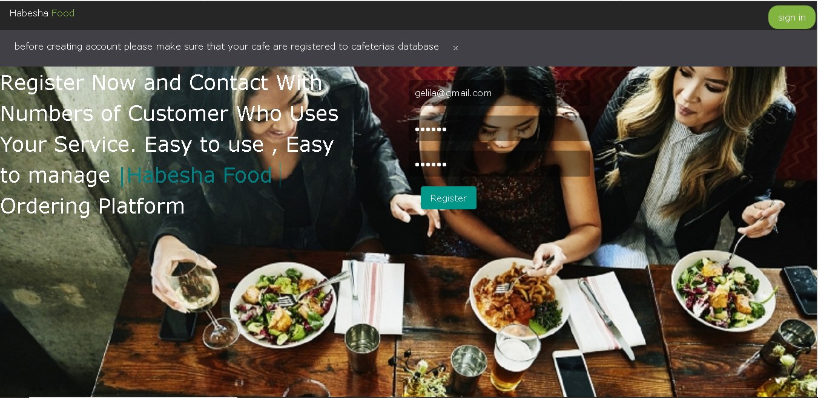

Figure 42: Registration Page for Providers

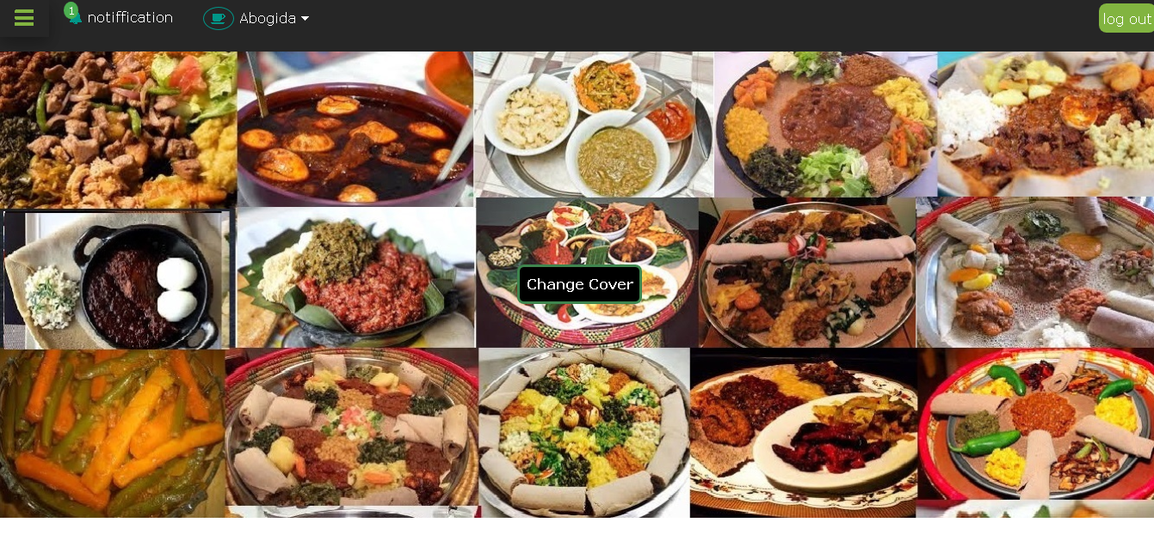

Figure 43: Home Page for Victual Provider

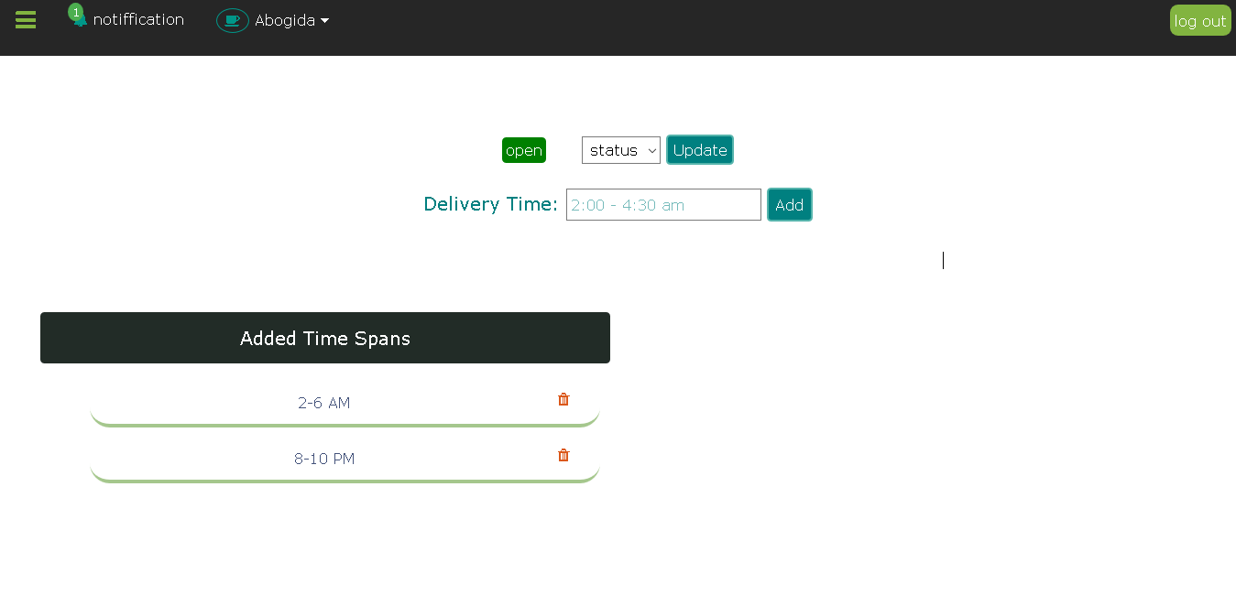

Figure 44: Add Delivery Schedule Page

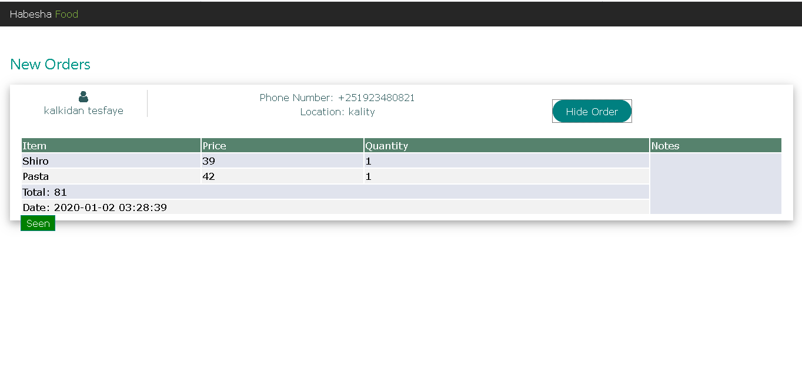

Figure 45: Order History Page

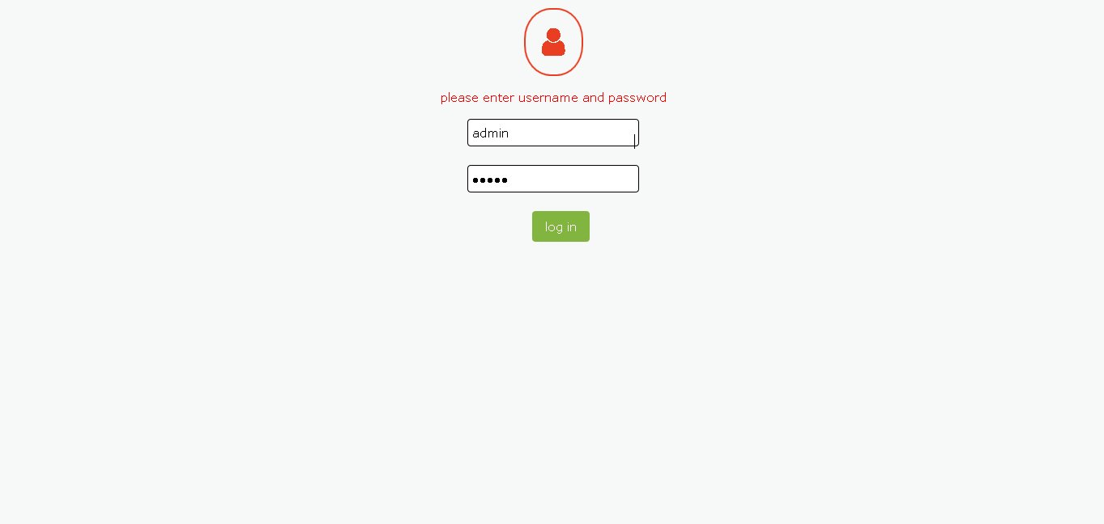

Figure 46: Admin Login Page

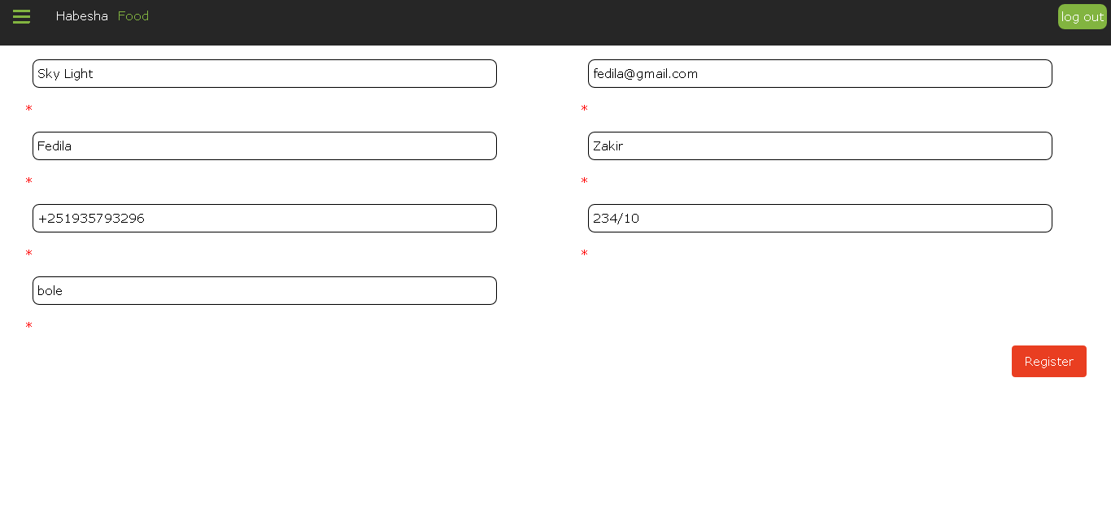

Figure 47: Victual Provider Registration Page

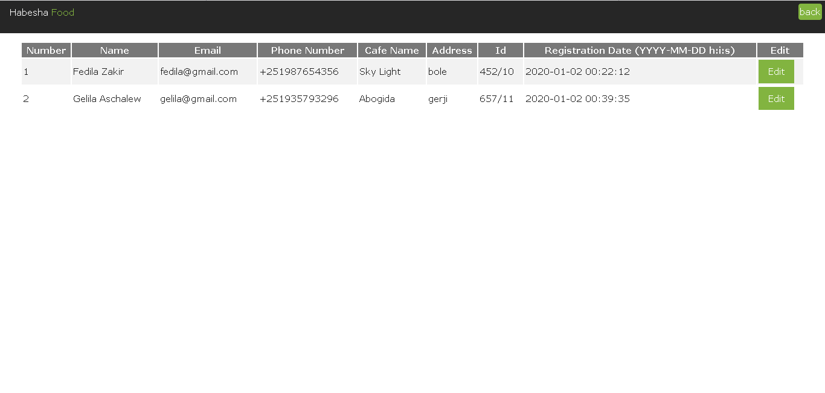

Figure 48: Registered Victual Providers Page

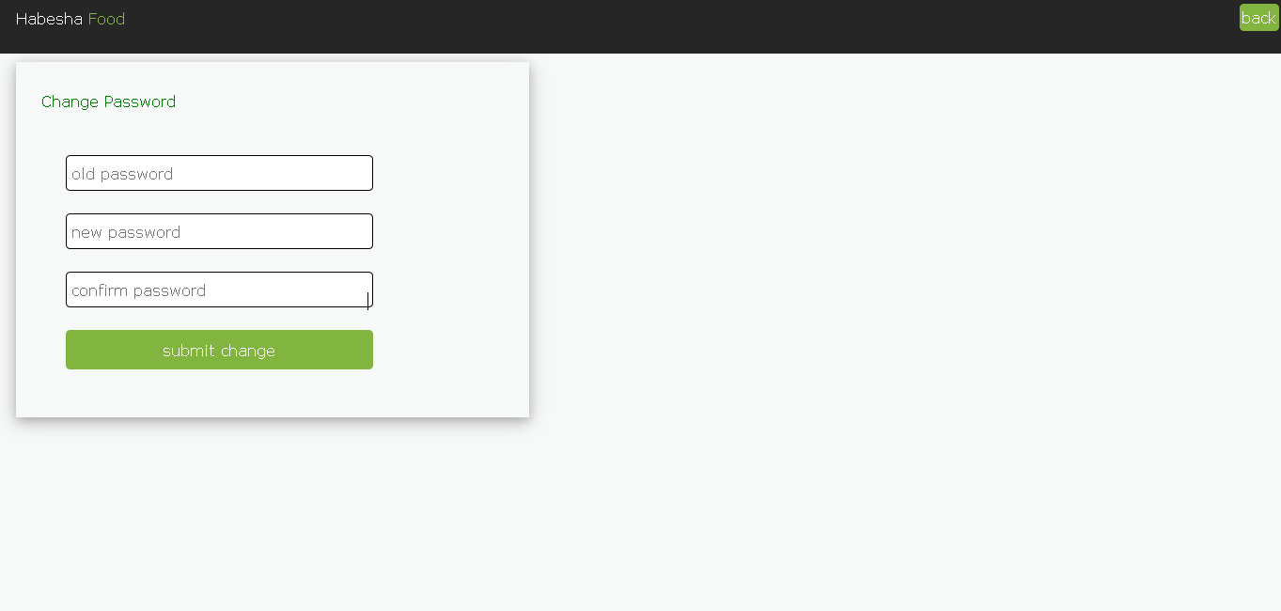

Figure 49: Change Password Page

# Chapter Five: Implementation and Testing

## Implementation

Implementation is a phase in SDLC in which the physical system specifications are converted in to a working and reliable solution. The whole team gathered and created the actual project. We classified the project into two sections namely the front end and back end. In the front end, it is mostly focused on what some coin the client side of development. Therefore, the front end manages everything that users visually see first in their browser or application. In the backend, it is focused on how the application works. Making updates and changes in addition to monitoring functionality of the application is its primary responsibility.

### 5.1.1 Front End Source Code

### Sample Component Class for Login

import { Router } from '@angular/router';

import { TokenService } from './../services/token.service';

import { RequestHandlerService } from './../services/request-handler.service';

import { FormGroup, FormControl, Validators } from '@angular/forms';

import { Component, OnInit } from '@angular/core';

@Component({ selector: 'app-login', templateUrl: './login.component.html', styleUrls: ['./login.component.css']

})

export class LoginComponent implements OnInit {

public loginForm;

public loginError={error:false,errorMessage:''};

constructor (private requestHandler: RequestHandlerService, private token:TokenService, private router : Router) { }

ngOnInit() {

this.loginForm = new FormGroup({

email: new FormControl(''),

password: new FormControl('')

});

}

onSubmit(){

if(this.loginForm.valid)

{

this.requestHandler.customerLogin(this.loginForm.value).subscribe( data=>

{ this.handleResponse(data);

if(data['role']=="customer"){

this.router.navigate(['customer-home']);

}

else if(data['role']=="vendor")

{

this.router.navigate(['vendor-home']);

} },

error=>{ this.loginError.errorMessage=error.error.error; this.loginError.error=true;

}

}

}

handleResponse(data){

localStorage.setItem("role", data.role);

this.token.set(data.access_token, data.id);

this.requestHandler.setUser();

}

}

### Sample for Track location

import { AfterViewInit, ViewChild, ElementRef, Component, OnInit } from '@angular/core';

import * as L from 'leaflet';

import 'mapbox-gl-leaflet';

import { Router } from '@angular/router';

const iconRetinaUrl = 'assets/marker-icon-2x.png';

const iconUrl = 'assets/marker-icon.png';

const shadowUrl = 'assets/marker-shadow.png';

const iconDefault = L.icon({

iconRetinaUrl iconUrl,shadowUrl,iconSize: [25, 41], iconAnchor: [12, 41], popupAnchor: [1, -34], tooltipAnchor: [16, -28], shadowSize: [41, 41]

} );

L.Marker.prototype.options.icon = iconDefault

@Component({

selector: 'app-view-location', templateUrl: './view-location.component.html', styleUrls: ['./view-location.component.css']

} )

export class ViewLocationComponent implements OnInit

{

private map: L.Map;

@ViewChild('map', {static: false} )

private mapContainer: ElementRef<HTMLElement>;

public latitude;

public longitude;

constructor(private route: Router) { }

ngOnInit() {

}

ngAfterViewInit() {

const myAPIKey = "fe647d3830ed4021b3f8a9dfcd31076b";

const mapStyle = "https://maps.geoapify.com/v1/styles/osm-carto/style.json";

const initialState = {

lng: this.longitude, lat: this.latitude, zoom: 12

} ;

const map = new L.Map(this.mapContainer.nativeElement).setView( [initialState.lat, initialState.lng], initialState.zoom

) ;

// the attribution is required for the Geoapify Free tariff plan.

map.attributionControl

.setPrefix("")

.addAttribution(

'Powered by <a href="https://www.geoapify.com/" target="_blank">Geoapify</a> | © OpenStreetMap <a href="https://www.openstreetmap.org/copyright" target="_blank">contributors</a>'

) ;

L.mapboxGL ( {

style: `${mapStyle}?apiKey=${myAPIKey}`, accessToken: "pk.eyJ1Ijoia2Fsa2lkYW50IiwiYSI6ImNrajQ4ZGZhNTJqNHcydG54ZHk0aWw5enEifQ.Ay5QkbatF1jMzgMlMOSIZA"

} ).addTo(map);

let marker = L.marker([initialState.lat, initialState.lng],{title: `you are on ${this.latitude}, ${this.longitude}`, draggable: true}).

addTo(map)

// on ('dragend', function () {

// var coord = String (marker.getLatLng()).split(',');

// this.latitude = coord[0].split('(')[1];

// this.longitude = coord[1].split(')')[0];

// localStorage.setItem("moved-latitude", this.latitude);

// localStorage.setItem("moved-longitude", this.longitude);

// marker.bindPopup("Moved to: " + this.latitude + ", " + this.longitude + ".");

// } ) ;

var popup = marker.bindPopup('<b>Hello !</b><br />please choose your location and click on select a delivery location.') ; popup.openPopup () ;

}

}

### Sample for Customer Registration

import { RequestHandlerService } from './../../services/request-handler.service';

import { TokenService } from './../../services/token.service';

import { Component, OnInit } from '@angular/core';

import { FormBuilder, Validators } from '@angular/forms';

import { Router } from '@angular/router';

@Component({

selector: 'app-customer-registration',

templateUrl: './customer-registration.component.html',

styleUrls: ['./customer-registration.component.css']

})

export class CustomerRegistrationComponent implements OnInit {

public togglePasswordValue = 'show';

public registrationForm;

public disableSubmit=false;

public startLoading=false;

publicemailError={error:false,message:''}; constructor(privatefb:FormBuilder,private apiRequest :RequestHandlerService ,private token: TokenService,private router:Router){ }

ngOnInit() {

this.registrationForm = this.fb.group(

{ firstname:[''],astname:[''],gender:['',[Validators.required]],email:[''],phonenumber:[''], password:[''],} ); }

togglePassword($input) {

if ( $input.type === 'password' ) {

$input.type = 'text' ;

this.togglePasswordValue = 'hide';

} else {

$input.type = 'password' ;

this.togglePasswordValue = 'show';

}

}

onSubmit(){

this.disableSubmit=true;

this.startLoading=true;

this.registrationForm.value.role = "customer";

this.apiRequest.signup(this.registrationForm.value).subscribe(

data=>{

console.log(data);

this.handleResponse(data);

},

error=>{

console.log(error);

this.emailError.error=true;

this.emailError.message=error.error.errors.email[0]; }

); }

handleResponse(data){

this.token.set(data.access_token, data.id);

if(data.role == "customer"){

setTimeout(()=>{

this.router.navigate(['customer-home']);

},4000);

}}

### 5.1.2 Back End Source Code

### Sample for Order management

<?php

namespace App\Http\Controllers;

use Illuminate\Http\Request;

use Illuminate\Support\Facades\Validator;

use Illuminate\Support\Facades\DB;

use App\Order;

use App\Cart;

use App\OrderItem;

class OrderController extends Controller

{

public function placeOrder(Request $request){

$orderValidator = Validator::make($request->order, [

'vendor_id'=>'numeric|required|exists:users,id',

'user_id'=>'numeric|required|exists:users,id',

'latitude'=>'numeric',

'logitude'=>'numeric',

'order_delivered'=>'numeric',

'order_type '=>'string|max:200',

'total'=>'numeric|gt:0',

'sub_total'=>'numeric|gt:0',

'status '=>'string|max:200',

'payment_type '=>'string|max:200',

'note '=>'string|max:2000'

]);

if ($orderValidator->fails()) {

return response()->json($orderValidator);

}

foreach($request->orderItems as $orderItem){

$validator = Validator::make($orderItem, [

'menu_id'=>'numeric|required|exists:menus,id',

'user_id'=>'numeric|required|exists:users,id',

'price'=>'numeric|required|gt:0',

'name'=>'string|required',

'quantity'=>'numeric|required|gt:0'

]);

if ($validator->fails()) {

return response()->json($validator);

}

}

try {

$deletedRow = Cart::where('user_id', '=', $request->order['user_id'])->delete();

$order = Order::create($request->order);

if($order){

$orderItems = [];

for ($i=0; $i < count($request->orderItems); $i++) {

OrderItem::create(["order_id"=>$order['id'], "menu_id"=>$request->orderItems[$i]['menu_id'], "price"=>$request->orderItems[$i]['price'], "name"=>$request->orderItems[$i]['name'], "quantity"=>$request->orderItems[$i]['quantity']]);

}

return response()->json(["status"=>true, "message"=>"order placed successfully", "order"=>$order]);

}

else{

return response()->json(["error" => "couldn't place order", "status"=>false], 400);

}

} catch (Exception $e) {

return response()->json(["error" => $e->getMessage(), "status"=>false], 500);

}

}

public function getVendorOrders($vendor_id){

$orders = Order::where('vendor_id', $vendor_id)

->join('users', 'users.id', '=', 'orders.user_id')

->select('orders.*', 'users.firstName', 'users.lastName', 'users.address', 'users.phoneNumber', 'users.email')

->orderBy('created_at', 'desc')

->get();

return response()->json($orders);

}

public function getOrderItems($orderId){

$orderItems = OrderItem::where('order_id', $orderId)->get();

return response()->json($orderItems);

}

public function updateSeen($id){

$order = Order::find($id);

$order->seen = 1;

$order->save();

return response()->json(["status"=>true]);

}

public function getNumberOfOrders($vendor_id){

$orders = Order::where('vendor_id', $vendor_id)

->where('seen', 0)

->get();

$orderNumber = $orders->count();

return response()->json($orderNumber);

}

public function markAsServed($order_id){

try {

$orders = Order::where('id', $order_id)

->update(['order_delivered' => 1]);

return response()->json(["status"=>true, "message"=>"order marked as served"]);

} catch (Exception $e) {

return response()->json(["status"=>false, $e->getMessage()], 500);

}

}

}

class OrderItems{

public $menu_id;

public $user_id;

public $price;

public $name;

public $quantity;

public $order_id;

public function __construct($menu_id, $user_id, $price, $name, $quantity, $order_id) {

$this->menu_id = $menu_id;

$this->user_id = $user_id;

$this->price = $price;

$this->name = $name;

$this->quantity = $name;

$this->order_id = $order_id;

}

}

### Sample for Cart system

<?php

namespace App\Http\Controllers;

use Illuminate\Http\Request;

use App\Cart;

use App\User;

use App\Menu;

use Illuminate\Support\Facades\Auth;

use Validator;

class CartController extends Controller

{

public function add(Request $request){

$request->validate(['user_id'=>'required|numeric','menu_id'=>'required|numeric','vendor_id'=>'required|numeric']) ;

$vendor = User::find($request->vendor_id);

$cart = Cart::where('menu_id', $request->menu_id)->where('user_id', $request->user_id)->first();

if(Auth::id()!==$request->user_id){

return response()->json(["error"=>true, "message"=>"you are not authorized"], 401);

}

else if (empty($vendor)){

return response()->json(["error"=>true, "message"=>"vendor not found"], 404);

}

else if($cart){

return response()->json(["error"=>true, "message"=>"the menu is already added"], 400);

}

try {

$cart = Cart::create($request->all());

return response()->json(["status"=>true, "message"=>"cart created", "cart"=>$cart]);

} catch (Exception $e) {

response()->json(["error"=>true, "message"=>$e->getMessage()], 400);

}

}

public function getCarts($id){

$carts = [];

try {

$fetchedCarts = Cart::where('user_id',$id)->get();

foreach ($fetchedCarts as $index=>$cart) {

$menu_id = $cart->menu_id;

$vendor_id = $cart->vendor_id;

$id = $cart->id;

$menu = Menu::find($menu_id);

$name = $menu->name;

$price = $menu->price;

$quantity = $cart->quantity;

$returnedCart= new ReturnedCart($id,$vendor_id,$menu_id,$name, $price,$quantity);

$carts[$index] = $returnedCart;

}

return response()->json(["status"=>true, "carts"=>$carts]);

} catch (Exception $e) {

return response()->json(["error"=>true, "message"=>$e->getMessage()]);

}

}

public function updateQuantity($id){

try {

$cart = Cart::find($id);

if(empty($cart)){

return response()->json(["error"=>true, "message "=>"id $id not found"], 404);

}

$cart->save();

return response()->json(["status"=>true, "message "=>"quantity updated successfuly"]);

} catch (Exception $e) { return response()->json(["error"=>true, "message"=>$e->getMessage()]);

}

}

public function delete($id){

try {

$deletedCart = Cart::where('id',$id)->delete();

if($deletedCart>0){

return response()->json(["status"=>true, "message"=>"cart deleted"]);

}

else{

return response()->json(["error"=>true, "message"=>"cart id $id not found"], 404);

}

} catch (Exception $e) {

response()->json(["error"=>true, "message"=>$e->getMessage()], 400);

}

}

public function getTotalPrice($userId){

try {

$carts = User::find($userId)->cart();

$total=0;

foreach ($carts as $cart) {

$menu = $cart->menu();

$quantity = $cart->quantity;

$singlePrice = $menu->price * $quantity;

$total+=$singlePrice;

}

return response()->json(["status"=>true, "totalPrice"=>$total]);

} catch (Exception $e) {

response()->json(["error"=>true, "message"=>$e->getMessage()], 400);

}

}

}

class ReturnedCart {

public function __construct($id, $vendorId, $menu_id, $name, $price, $quantity){

$this->id = $id;

$this->vendorId = $vendorId;

$this->name = $name;

$this->price = $price;

$this->quantity = $quantity;

$this->menu_id = $menu_id;

}

public $id;

public $menu_id;

public $vendorId;

public $name;

public $price;

public $quantity;

}

## 5.2 Testing

Software testing is the process of evaluation of a software item to detect differences between given input and expected output. The testing assess the quality of the product. Testing helps us to identify whether the implemented system is working as per requirement or not. So we perform our test in two ways

Firstly: Testing done during development phase. This testing includes:

* Syntax error testing: this method of testing is used to check all the syntax errors during the development.
* Compatibility testing: this testing is used to test if all the languages used during the programming were compatible with each other.

Secondly: testing done by running the software on realistic data samples. This testing includes:

* Running the application in its fullness using a local server Xampp server, that have local host which is using Apache as engine and MYSQL as the database.

|  |  |  |  |  |  |  |
| --- | --- | --- | --- | --- | --- | --- |
| Id | Test  Case | Description | Input |  | Expected Result | Remark |
| 1 | Register | The Victual provider registration by  Admin is tested by enter the victual provider’s data and click the Register button. | . If the Admin enters valid information |  | Save the data on the database and the registered victual provider can have access to the system by setting up their password. | The system provides access to the system. |
| 2 | Register | The Victual provider registration by  Admin is tested by enter the victual provider’s data and click the Register button. | If the victual provider enters invalid information. |  | registration will be denied,  an error message will be displayed,  the actor will be asked to retry | Display registration error message and ask to reenter registration form. |
| 3 | Create account | The user open the registration page.  Fill the form and hit submit. | If the user enters valid information. |  | After creating account actors can have access to the system and log in page | The system provide  Log in page |
| 4 | Create account | The user open the registration page.  Fill the form and hit submit. | If the user enters invalid information. |  | Registration will be denied,  an error message will be displayed,  the actor will be asked to retry | Registration is denied, an error message displayed. |
| 5 | Log in | The login functionality of the system is tested by providing it login credentials. | If Correct (Valid) Email and correct password. |  | Home page based on the role of the logged in user. | The system provides the user relevant homepage to the user. |
| 6 | Log in | The login functionality of the system is tested by providing it login credentials. | If in the system cannot find the username or the password is invalid |  | An error message is displayed.  The actor can type in a new username and password. | System displayed error message is.  And ask to a new username and password or choose to cancel the operation |
| 7 | Search | The search functionality of the system is tested by find results that much the customer searches. | If victual providers that are already registered on the platform. |  | It will be presented with a list of victual providers that much their search. | System shows list of victual providers that much their search. |
| 8 | Search | The search functionality of the system is tested by find results that much the customer searches. | If victual providers that are not registered on the platform |  | It will display “Search Result Not Found” message will be displayed. | System shows  “Search Result Not Found”. |
| 9 | Order | The customer add item to cart and click on the order button. | If customer add item to cart and providers are open for service. |  | There must be orders made in the system. | System shows  Orders made sign. |
| 10 | Order | The customer add item to cart and click on the order button. | If customer not add item to cart and providers are open for service. |  | It will display  “Frist add item to cart or it show provider status”. | “Frist add item to cart or it show provider status”.is displayed. |
| 11 | Update personal information | Actor update personal information like password, name, and location tested by Enter updated data on the input they want to be updated and then click on update button. | The system check and if the data entered is valid. |  | The system will update the data on the database.  Display success message. | The system update the data on the database.  Display success message. |
| 12 | Update personal information | Actor update personal information like password, name, and location tested by Enter updated data on the input they want to be updated and then click on update button. | The system check and if the data entered is not valid. |  | There will not be update on the database, error message will be displayed and  The actor will be asked to retry. | System displayed “error message”  and  The actor asked to retry. |
| 13 | Edit menu | Victual provider add, delete and customize their menu and then click on update button. | If the actor enter valid information. |  | The system will update the added or deleted menu in the database.  The system will reflect the change on the website. | The system update the added or deleted menu in the database and reflect the change on the website. |
| 14 | Edit menu | Victual provider add, delete and customize their menu and then click on update button. | If the actor enter invalid information. |  | There will not be update on the database  error message will be displayed,  the actor will be asked to retry | No update on the database and error message displayed. |
| 15 | Change password | The change password functionality is tested with invalid or inappropriate passwords. | Incorrect current and invalid new password. Or incorrect current and correct password Or correct current and invalid new password. |  | The user is asked to reenter correct and valid passwords. | The user is asked to reenter correct and valid passwords. |
| 16 | Change password | The change password functionality is tested with invalid or inappropriate passwords. | Correct current password and new valid password. |  | The system changes the passwords for the user. Updates in the database. | The system changes the passwords for the user. Updates in the database. |
| 17 | Reset password | The ‘reset password’ functionality is tested with invalid resetting credential. | Invalid or unregistered email. |  | The user is asked to reenter a valid or registered email. | The user is asked to reenter a valid or registered email. |
| 18 | Reset password | The ‘reset password’ functionality is tested with invalid resetting credential. | Valid and registered email. |  | The password of the user will be reset. | The password of the user is rested. |

Table 25: Test Cases for System Functionalities

# Chapter six- Conclusion and Future Works

## 6.1 Future works

In the future, we plan to extend the project and make the entire online payment system automated and we will develop Mobile application. We hope to get feedbacks regarding the current system and improve its quality even further. After deployment, by investigating the degree to which it improves the current on line ordering process we will make modifications on the current system and work hard to further automate the whole system.

## Conclusion

To conclude the work in this project, the proposed solutions that are stated on the proposal part of the project are more properly implemented. The development of web based application for “Digital Platform for Victual Providers” could be hindered due to some constraint as time, money and mainly performance. These factors along with other unspecified reasons have resisted the team from developing more efficient and rich application.

# **Reference**

|  |  |
| --- | --- |
| [1] | "study.com," [Online]. Available: https://study.com/academy/lesson/scenario-based-requirements-modeling-definition-application.html. |
| [2] | "geeksforgeeks.org," [Online]. Available: https://www.geeksforgeeks.org/unified-modeling-language-uml-activity-diagrams/. |
| [3] | "www.tutorialspoint.com/object_oriented_analysis_desig," [Online]. Available: https://www.tutorialspoint.com/object_oriented_analysis_design/ooad_dynamic_modeling.htm. |
| [4] | "www.visual-paradigm.com/guide/uml-unified-modeling-language," [Online]. Available: https://www.visual-paradigm.com/guide/uml-unified-modeling-language/what-is-sequence-diagram/. |
| [5] | "www.smartdraw.com/state-diagram," [Online]. Available: https://www.smartdraw.com/state-diagram/. |
| [6] | "www.slideshare.net/MalekSumaiya/object-oriented-modeling-and-design-with-uml," [Online]. Available: https://www.slideshare.net/MalekSumaiya/object-oriented-modeling-and-design-with-uml. |
| [7] | "www.techopedia.com/definition/29998/system-design," [Online]. Available: https://www.techopedia.com/definition/29998/system-design. |
| [8] | "www.accu.org/index.php/journals/1585," [Online]. Available: https://accu.org/index.php/journals/1585. |
| [9] | "en.wikipedia.org/wiki/Robustness," [Online]. Available: https://en.wikipedia.org/wiki/Robustness. |
| [1] | "www.mindtools.com/pages/article/flexibility-at-work.htm," [Online]. Available: https://www.mindtools.com/pages/article/flexibility-at-work.htm. |
| [1] | "en.wikipedia.org/wiki/Architectural_style," [Online]. Available: https://en.wikipedia.org/wiki/Architectural_style. |
| [1] | "en.wikipedia.org/wiki/Architectural_pattern," [Online]. Available: https://en.wikipedia.org/wiki/Architectural_pattern. |
| [13 | "www.tutorialspoint.com/uml/uml_component_diagram.htm," [Online]. Available: https://www.tutorialspoint.com/uml/uml_component_diagram.htm. |
| [1] | "www.creately.com/blog/diagrams/deployment-diagram-tutorial/," [Online]. Available: https://creately.com/blog/diagrams/deployment-diagram-tutorial/. |
| [15] | "www.medium.com/the-andela-way/system-design-in-software-development-f360ce6fcbb9," [Online]. Available: https://medium.com/the-andela-way/system-design-in-software-development-f360ce6fcbb9. |
| [16] | "www.researchgate.net/publication/232815556_Flexibility_in_e-Business_Strategy_A_requirement_for_Success," [Online]. Available: https://www.researchgate.net/publication/232815556_Flexibility_in_e-Business_Strategy_A_requirement_for_Success. |
| [17] | "en.wikipedia.org/wiki/Software_documentation," [Online]. Available: https://en.wikipedia.org/wiki/Software_documentation. |
| [18] | "www.searchsecurity.techtarget.com/definition/access-control," [Online]. Available: https://searchsecurity.techtarget.com/definition/access-control. |